ECO VISION: ENERGY EFFICIENT STREET LIGHTING SYSTEM WITH SENSOR AND CAMERA-BASED FOR LOCALIZED CRIME DETECTION

A Capstone Project
Presented to the Faculty of the
College of ICT and Engineering
Western Leyte College of Ormoc Inc.
Ormoc City, Leyte

In Partial Fulfillment of the
Requirements for the Degree of
BACHELOR OF SCIENCE IN COMPUTER ENGINEERING

By:

Torres, Angel Venice C.
Dela Cruz, Fritz Rjhay
Perez, Reiss Mea A.

Engr. Gamaliel B. Peliño, MSIT(CAND)
Adviser

April 2026

APPROVAL SHEET

The Capstone Project ENERGY EFFICIENT STREET LIGHTING SYSTEM WITH SENSOR AND CAMERA-BASED FOR LOCALIZED CRIME DETECTION prepared and submitted by Angel Venice C. Torres, Fritz Rjhay L. Dela Cruz and Reiss Mea A. Perez in partial fulfillment of the requirements for the degree of BACHELOR OF SCIENCE IN COMPUTER ENGINEERING has been examined and is recommended for approval and acceptance for ORAL DEFENSE.

CAPSTONE PROJECT COMMITTEE

ENGR. GAMALIEL B. PELIÑO, MSIT(CAND) ______________________
Adviser Member
______________________ ______________________
Member Member
______________________
Chairman
PANEL OF EXAMINERS
Approved by the committee on Oral Defense with a grade of _______.

ENGR. GAMALIEL B. PELIÑO, MSIT(CAND) ______________________
Adviser Member
______________________ ______________________
Member Member
______________________
Chairman
________________
Date of Oral Defense

CHERYL M. TARRE, DBA (cand.), MST – CS, MSCS
Dean, College of ICT and Engineering
ii
ABSTRACT

This study covers the design, development, and evaluation of EcoVision, an energy-efficient street lighting system with sensor and camera-based localized crime detection, intended for barangay-level deployment. The system integrates a solar-powered smart pole with adaptive LED lighting, a passive infrared sensor, a panic button, a siren, and a camera running a locally-executed machine learning model for violence detection. Violence detection uses X3D-XS, a three-dimensional convolutional neural network operating on 13-frame clips, fine-tuned from Kinetics-400 pretrained weights on 7,630 clips drawn from four public benchmark datasets and 2,103 clips captured from Philippine live street cameras. A YOLO11 network performs person and pose detection as a separate stage. On 932 clips withheld from training, the deployed model achieves 91.4% recall at a 12.9% false-positive rate. On three continuously-recorded Philippine street cameras never used in training, it produces 32 alarms per hour, reduced from 41 by the addition of locally-captured negative footage. The study additionally reports two findings that constrain how such systems should be evaluated. First, clip-level false-positive rate on benchmark data was found not to predict false alarms on a continuously-running camera: three model checkpoints scored statistically indistinguishable benchmark rates while their real-camera alarm rates differed by a factor of 13.5. Second, four pose-derived filtering strategies, together with tiled multi-region inference, were each measured and found to perform worse than a single threshold adjustment, indicating that for this class of model the operating point and the training data, rather than additional inference-time machinery, govern practical accuracy.
October 2026 update. After the results above were obtained, the detectors and the evaluation protocol were extended, and the figures in this paragraph supersede the corresponding figures above. The violence detector now averages two X3D-XS models and confirms each alarm against crops around the people present; robbery and vandalism, previously rule-based, are learned X3D-XS classifiers labelled experimental; and the weapon detector was retrained at higher resolution on 7,500 synthetic street-camera frames. A second-stage check was added in which a small vision-language model, Qwen3-VL-2B, is asked a yes-or-no question about the two seconds preceding each alarm; the model is used as released, and only its pass-or-fail cut-offs were fitted. Measured on 200 held-out fights spliced into continuous footage and on five hours of held-out street cameras, the check raised the share of fights caught from 88.0 to 94.0 percent (95 percent confidence interval 89.8 to 96.5) while false alarms fell from 1.4 to 0.4 per hour; raised the share of robbery events correctly labelled from 8.3 to 59.4 percent (50.9 to 67.4); and halved false armed-threat alerts from 2.8 to 1.4 per hour. The robbery gain is clearly significant and the fight gain is marginal under a conservative unpaired test; the false-alarm reductions rest on between one and fourteen alarms per setting and are not individually significant. Recall on the deployment cameras remains unmeasured.

iii
ACKNOWLEDGEMENT

The researchers would like to express their heartfelt gratitude to the people listed below who assisted them in making this study a reality.

First and foremost, they thank the Almighty God for all the blessings they've received, as well as for providing them with constant strength, good health, guidance, and wisdom.

To their cherished families, especially their parents, who supported them throughout the ups and downs to make these things possible.

To Eng. Gamaliel B. Peliño, their capstone adviser, for always being there despite his hectic schedule, for sharing his immense knowledge in electronics, and for helping them to be challenged and to be better themselves as students and human beings.

To Mrs. Cheryl M. Tarre, their Dean, for being patient and understanding, as well as believing in and motivating the researchers; that they can do anything. For constantly reminding students to enroll and that if they want to graduate, they must finish their project.

To Engr. Alexander M. Co Hat, their statistician, for making mathematics as simple as possible and seeing every probability in solving multiple problems.

To Mrs. Myra Belle S. Fiel, their grammarian, for proofreading their project documentation's grammar and spelling.

To all of their instructors, for the overwhelming support.

iv
To the Ormoc City Police Office and Barangay Cogon, Ormoc City for providing the students with the information they needed for their research project.

To the RS Cherry for providing the components and any parts they needed for their research project.

To their classmates and schoolmates for making their college years fun and unforgettable despite every struggle.

Notwithstanding the sleepless nights, exhausting mornings, restless afternoons, doubts, and trials and errors, the students keep their heads up and move forward. Cheers to the trying days that turned out to be enjoyable and memorable while working on the capstone project.

THANK YOU SO MUCH!

v
DEDICATION

It is the researchers' genuine gratitude and warmest regard that they dedicate this work to their parents, who taught them that having a positive mindset is the key to overcoming every struggle in life. Furthermore, the researchers did this not just to meet the requirements but also out of a desire to see this project succeed and for the better of their futures.

vi
TABLE OF CONTENTS
TITLE ………………………………………………………………………………………….i
APRROVALSHEET …………………………………………………………………………ii
ABSTRACT .……………………………………………………………………………......iii
ACKNOWLEDGEMENT ……………………………………………………………...…….iv
DEDICATION ..……………………………………………………………….……..............vi
TABLE OF CONTENTS ……………………………………………………….……….…...vii
LIST OF FIGURES………………………………………………………………x
LIST OF TABLES……………………………………………………………….xii

CHAPTER 1: THE PROBLEM AND ITS SCOPE / INTRODUCTION……..……………..1
Rationale of the Project ……...……………………………………………..…..……1
Objectives of the Project ………………………………………………………..3
Scopes and Limitations of the Project .….…………………………………………….4
Significance of the Study ………..…………………………………………………….6
Flow of the Study ……...………………..……………………………………………..7
Definition of terms .…………………………………..………………….……...8

CHAPTER 2: REVIEW OF RELATED LITERATURE AND STUDIES……..…….…….10
Related Theories ……...…………………………………………………..…..……10
Adaptive Lighting Control Theory………………………………………...…….10
Computer Vision & Machine Learning Theory (YOLO Algorithm)…….…..10
Smart City Framework (Cisco & IBM IoT Concepts)……………………….11
Energy Management Theory (Demand-Side Management)…………………11
Related Studies………………………………………………………………………11
Legal Basis………………………………………………………………………...…13
Republic Act No. 11032 — Ease of Doing Business Act……………………13
Republic Act No. 10173 — Data Privacy Act………………………………..13
vii
Philippine Green Building Code (Referral Code of PD 1096)……………… 14
DOE Circulars (RA 11285 – Energy Efficiency and Conservation Act)…….14
Republic Act No. 7160 — Local Government Code……………………….14
Republic Act No. 9003 — Ecological Solid Waste Management Act………14

CHAPTER 3: CAPSTONE PROJECT METHODOLOGY…………………………….…18
Research Design …………………………………………………………………………18
Participants of the Study………………………………………………………………....18
Research Locale………………………………………………………………………....18
Data Gathering Procedure……………………………………………………………….18
Preparation Phase……………………………………………………………….,19
Data Collection Phase……………………………………………………………19
System Development Life Cycle……………………………………….……………...20
Project Environment…………………………………………………………………..20
Software Engineering Methods…………………………………………………21
Planning and Idea Conception………………………………………………………..22
Gantt Chart……………………………………………………………………….21
Business Model Canvas………………………………………………………….23
Functional Decomposition……………………………………………………….24
Conceptual Framework…………………………………………………………..26
Analysis and Design Phase………………………………………………………………27
Use Case Diagram……………………………………………………………….27
Prototype Design…………………………………………………………………28
Development Phase………………………………………………………………………29
Software Development Specifications………………….………………….29
Arduino IDE………………………………………………………….29
SketchUp……………………………………………………………..29
Fritzing………………………………………………………………..30
viii
Proteus 8……………………………………………………………..30
Fusion 360……………………………………………………………30
Roboflow……………………………………………………………..31
Visual Studio Code…………………………………………………..31
AutoCAD…………………………………………………………….31
Microsoft Office Word………………………………………………32
Microsoft Office Power Point……………………………………….32
Hardware Development S…………………………………………………..33
Pole System…………………………………………………………………33
ESP32 Microcontroller………………………………………………33
Siren………………………………………………………………….33
Button………………………………………………………………..34
LiFePO Battery (12V 50Ah)………………………………………...34
Relay Module………………………………………………………..34
Optocoupler Module…………………………………………………35
LM2596 Buck Converter.……………………………………………35
Solar Charger………………………………………………………...35
Buck Boost Converter………………………………………………36
Solar Tracker………………………………………………………………..36
Solar Panel……………………………………………………………36
Light Dependent Resistor…………………………………………….27
Light………………………………………………………………………….37
Solar Street Light……………………………………………………..37
Testing Phase………………………………………………………………..38
Unit Testing…………………………………………………………38

CHAPTER 4: FINDINGS AND CONCLUSIONS…………………………………
ix
LIST OF FIGURES

Figure # Description Page #
Figure 1.1: Flow Diagram…………………………………………………………………………7
Figure 3.1: Software Engineering Methods……………………………………………………...21
Figure 3.2: Gantt Chart…………………………………………………………………………..23
Figure 3.3: Business Model Canvas……………………………………………………………..24
Figure 3.4: Functional Decomposition Diagram………………………………………………...25
Figure 3.5: Conceptual Framework……………………………………………………………...26
Figure 3.6: Use Case Diagram…………………………………………………………………..27
Figure 3.7: Prototype Design……………………………………………………………………28
Figure 3.8: Arduino IDE…………………………………………………………………………29
Figure 3.9: SketchUp…………………………………………………………………………….29
Figure 3.10: Fritzing……………………………………………………………………………..30
Figure 3.11: Proteus8…………………………………………………………………………….30
Figure 3.12: Fusion360…………………………………………………………………………..30
Figure 3.13: Roboflow…………………………………………………………………………...31
Figure 3.14: Visual Studio Code…………………………………………………………………31
Figure 3.15: AutoCAD…………………………………………………………………………...31
Figure 3.16: Microsoft Office Word……………………………………………………………..32
Figure3.17: Microsoft Office Power Point………………………………………………………32
Figure 3.18: ESP32 Microcontroller………..……………………………………………..……..33
Figure 3.19: Siren…………….………..…………………………………………………..……..33
Figure 3.20: Button………..………..…………………………………………………..………..34
Figure 3.21: LiFePO4 Battery (12V 50Ah)…..……………………………….………..………..34
Figure 3.22: Relay Module………..………………………………………………..……………34
Figure 3.23: Optocoupler Isolation Module.…..……………………………………..…………..35
Figure 3.24: LM2596 Buck Converter…………………………………………………………...35
x
Figure 3.25: Solar Charger…………………………………………………………………….....35
Figure 3.26: Buck Boost Converter……………………………………………………………...36
Figure 3.27: Solar Panel…………………………………………………………………….……36
Figure 3.28: Light Dependant Resistor…………………………………………………………..37
Figure 3.29: Solar Street Light…………………………………………………………………...37
Figure 3.30: Solar Panel Test…………………………………………………………………….38
Figure 3.31: Buck Boost Converter and Buck Converter Test…………………………………..39
Figure 3.32: Solar Charger Test…………………………………………………………………39
Figure 3.33: CCTV Camera Test………………………………………………………………...40
Figure 3.34: WiFi Test…………………………………………………………………………..40
Figure 3.35: Home Page Test……………………………………………………………………41
Figure 3.36: About Us…………………………………………………………………………...41
x

xi
LIST OF TABLES

Table # Description Page #
Table 2.1: Comparative Matrix of Related Studies……………………………………………..15
Table 3.1: Planning Tasks……………………………………………………………………….22

xii
CHAPTER I
THE PROBLEM AND ITS SCOPE
INTRODUCTION
RATIONALE OF THE PROJECT
Nowadays, traditional streetlights are more often used such as electrical grids. Although traditional streetlights play a vital role in ensuring safety for the people there are also drawbacks of the product to be considered. Moreover, aside from high cost and maintenance being expensive. According to Solar & Lighting (2022), grid electricity is made from fossil fuels that generate toxic carbon dioxide which is harmful to the environment.¹ While fossil fuels have historically driven industrialization and urban development, continuing to use cause severe environmental and economic risks. According to World meters (2023), at current consumption rates, global oil reserves could be depleted in approximately 47 years, natural gas in 52 years, and coal in 133 years.² These fuels primarily cause Global Warming. In this context, the transition to Solar Street Lights (SSL)independent lighting systems powered by photovoltaic (PV) panels and rechargeable batteries—has become a critical step toward sustainability. A single solar streetlight can prevent approximately 200 kg of CO2 from entering the atmosphere annually, offering a 100% reduction in operational carbon emissions compared to traditional lighting.³

Despite these environmental issues, the primary function of street lighting remains the preservation of human safety. This statement is often viewed in "Broken Windows Theory," which hypothetically claims visible signs of disorder—such as broken infrastructure or dark, unmonitored streets—encouraging further criminal behavior. Globally, the correlation between visibility and crime reduction is well-documented. In 2019 NYC Crime Lab study, established that adequate nighttime illumination can reduce outdoor index crimes by approximately 36% and general crime rates by 21%.⁴ Similarly, in Safety Science 2010, the context of road safety, proper lighting has been shown to decrease nighttime traffic accidents by roughly 30%, lowering pedestrian fatalities and reducing resident fear by 50%.⁵
1
In the Philippines, recent crime and safety issues show that street-level infrastructure needs improvement. Data from the Philippine National Police (PNP) reveals a 61.87% nationwide drop in index crimes between July 2022 and mid-2024(PIA DMD 2024). Experts believe improved infrastructure, especially brighter street lighting, helps reduce crimes because criminals avoid well-lit places—such as theft and robbery—by eliminating dark spots and increasing natural surveillance. Furthermore, local studies in major cities like Quezon City and Iloilo corroborate that street lighting is a key factor in reducing road accidents on provincial roads.
However, a critical gap remains in the current infrastructure. While Local Government Units (LGUs) are increasingly adopting basic solar lighting to mitigate electricity costs—which can consume 40–65% of a municipality’s budget—most existing solutions are "passive." Traditional solar lights function solely as illumination sources; they cannot adapt to real-time changes in the environment, nor can they actively detect criminal activity or emergencies. As the Philippines moves towards a Smart City framework, there is a pressing demand for infrastructure that is not just energy-efficient but also data-driven.

This study proposes the development of a Smart Pole: an integrated, energy-efficient street lighting solution embedded with sensors and camera-based machine learning. Unlike standard solar lights, this system introduces "active" monitoring within a localized detection zone. By utilizing computer vision, the system is designed to distinguish between pedestrians and vehicles while specifically identifying three high-priority incidents: Physical Injury, Robbery, and Vandalism.
By focusing on near-field detection, the system provides clear monitoring in nearby areas where traditional streetlights often leave blind spots. With the use of machine learning, the system goes beyond basic lighting and acts as an active security tool that can deliver real-time data about its surroundings. This research aims to combine renewable energy with public safety by offering a dual-purpose solution that supports environmental sustainability while providing smart and targeted monitoring for modern urban security.
2
OBJECTIVES OF THE PROJECT

General Objective: The main objective of this study is to develop an energy-efficient smart street lighting system integrated with sensors and a camera-based machine learning module designed to detect specific urban incidents within a defined visual range to enhance local safety and resource management.

Specifically, this study aims to:
- To design an energy-saving street lighting system that lowers power consumption through efficient LED technology and intelligent brightness control.
- To implement a localized machine learning model capable of detecting physical violence between persons, supported by rule-based heuristics for robbery and vandalism indicators. (Revised October 2026: robbery and vandalism are now detected by learned classifiers, and every alarm is checked by a second model; see section 4.14.)
- To implement a system with panic buttons and sirens that provide real-time alerts and automated response emergencies.
- To optimize the detection algorithm for the full camera field of view, maintaining accuracy for incidents in which subjects occupy as little as nine percent of frame height.
- To evaluate the system’s performance by providing timely alerts and real-time data analysis for incidents detected within the system’s line-of-sight.
- To assess the reliability of smart poles in enhancing situational awareness and providing actionable data for city management and emergency response optimization.

3
SCOPE AND LIMITATIONS OF THE PROJECT
This research focuses on designing, developing, and testing a Solar-Powered Smart Pole with a hybrid energy backup, built for monitoring specific areas for security. Using local crime data, it focuses on detecting high-priority incidents as they happen.

Scopes of the Project:
- Targeted Incident Detection
- Violence Detection: The system detects physical violence between persons using a three-dimensional convolutional neural network trained on surveillance footage and executed locally on the pole.
- Robbery and Vandalism Indicators: These began as rule-based heuristics for visible weapons and tampering with infrastructure. As of October 2026 they are learned classifiers (X3D-XS video networks, labelled experimental in the application), with weapons detected separately by a YOLO11 object detector; see section 4.14.
- Person and Object Detection: A YOLO11 network locates persons and distinguishes pedestrians from vehicles, supporting both lighting control and incident context.
- Wide-Area Coverage: The system analyses the full camera field of view. Detection has been validated with subjects occupying as little as nine percent of frame height, corresponding to a wide street view.
- Tiered Activation Logic: Panic buttons or detected motion trigger the high-performance processing unit only when needed, conserving energy for night-time operation.
- Night Vision Capability: Integrated IR illuminators allow crime detection in low-light conditions.
- Hybrid Energy System: Solar power is the primary source, with automatic backup to the main electricity grid when battery levels are low.
- Active Deterrence and Alerts: When a crime is detected automatically by the camera or manually via panic button, the system triggers alarms (strobe lights and sirens) and sends detailed, priority alerts to a central dashboard via Wi-Fi.
- Hybrid Energy System: Solar power is the primary source, with automatic backup to the main electricity grid when battery levels are low.
- Active Deterrence and Alerts: When a crime is detected, automatically by the camera via panic button, the system triggers alarms (strobe lights and sirens) and sends detailed, priority alerts to a central dashboard via Wi-Fi.
4
Delimitations of the study:
- Recall on the deployment cameras is unmeasured. No labelled violent incident exists in the researchers' own camera footage. All recall figures derive from public benchmark datasets recorded in other countries. False alarms are measured directly on Philippine footage; detection performance is not.
- False-alarm rate varies by camera installation. Measured on the same day at identical settings, individual cameras produced between zero and 84 alarms per hour. A single system-wide figure is not meaningful without per-camera reporting.
- Pan-tilt-zoom cameras require per-position calibration. A camera in the test set was in motion during 18.6 percent of samples, with scale changes of negative seven to positive eight percent. A threshold calibrated at one framing is not valid at another.
- Robbery and vandalism detection are experimental. Robbery is the weakest detector (59.4 percent of 133 events labelled correctly, with the second-stage check), and vandalism was measured on only 31 acts drawn from few source videos.
- Detection footage is drawn from Davao City street cameras while the deployment locale is Barangay Cogon, Ormoc City. Both are Philippine urban street environments, but no footage from the deployment site itself was available during development.
- Privacy by design. No facial recognition or biometric identification is performed. The system classifies actions and locates objects; it does not identify individuals.
- Environmental sensitivity. Heavy rain, fog, and severe backlighting reduce accuracy. Night performance is measured; extreme weather is not.
SIGNIFICANCE OF THE STUDY

The development of a Smart Pole integrating solar energy, adaptive LED lighting, and camera-based machine learning—offers substantial contributions to public safety, environmental sustainability, and urban management.

The study then can benefit the following group of people:
- Public Safety and Crime Prevention: Unlike traditional passive lighting, this system provides targeted surveillance for high-priority incidents—specifically Physical Injury, Robbery, and Vandalism.
- Local Government Units (LGUs) and City Planners: It provides LGUs with an energy-efficient solution that reduces municipal electricity bills while providing detailed data on local security risks, so infrastructure can be placed more strategically.
- Support for Law Enforcement Agencies: By providing immediate alerts for specific crimes occurring within the camera's effective range, it enables law enforcement to respond to verified incidents more quickly, reducing the time spent on general area patrols.
- Environmental Sustainability: By combining renewable solar energy with ML-driven dimming controls, the system maximizes battery longevity.
- Academic and Future Research: This project adds to the field of Cyber-Physical Systems (CPS) by tackling the challenges of balancing machine learning processing, camera coverage limits, and solar energy availability. It provides a practical framework for future researchers who want to improve AI accuracy in systems with limited hardware and restricted monitoring areas.

6
FLOW OF THE STUDY

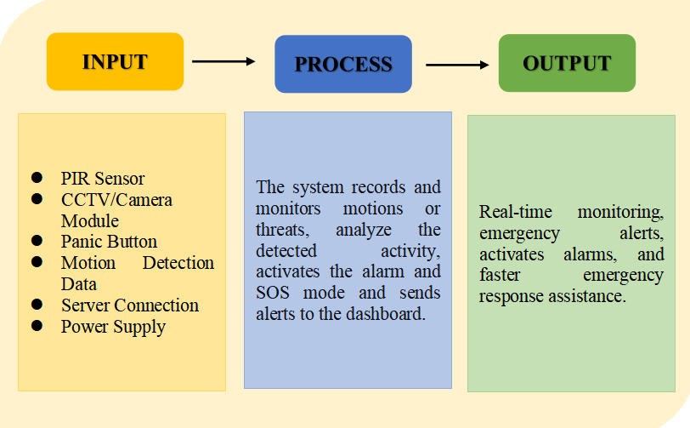
Figure 1.1: Flow of the Study

The figure above shows the flow of the system from its input, which includes user data and system requirements, to the processing stage where the system is developed and tested, up to its output.
DEFINITION OF TERMS
For better understanding of the study, the following are defined operationally and conceptually as used in this research:

Smart Pole - A modern street lighting structure that integrates solar power, LED lighting, sensors and camera-based monitoring system to provide both illumination and security functions.

Solar Street Light - This is a lighting system that powered by the solar energy using photovoltaic panel and a rechargeable batteries that is used as an alternative lighting to traditional grid-powered streetlights.

Photovoltaic Panel - This is a device that converts the sunlight into electrical energy, which is used to charge a battery system of the smart pole.

Machine Learning - This is a branch of artificial intelligence that enables the system to learn a patterns from data and make predictions without explicitly programmed.

Computer Vision - An artificial intelligence that allows the machines to interpret and analyze a visual information from the images or videos that captured by the camera.

Edge AI Processing - A computer approach where data processing and analysis are done locally on the smart pole instead of sending data on central server, allowing faster response times.

Physical Injury Detection - System function that identifies situations where a person appears to be physically harmed based on detected movements or behaviors within camera’s range.

Robbery Detection - Ability of a system that identify aggressive human behavior involving possible theft or the presence of weapons within the monitored area.
8
Vandalism Detection - Identification of intentional damage or destruction of property of infrastructure within the camera’s range.

Near-Field Monitoring - The detection approach that only focuses on activities within the limit range of the camera, approximately 5 - 7 meters to ensure the high accuracy and reduces processing load.

Hybrid Energy System - A dual power system that uses solar energy as a primary source and grid electricity as a back up when a battery levels are low.

Panic Button - This is a manual emergency button that installed the system, which allows user to immediately activate alerts and emergency responses.

Siren System - An audible alert system that activated when a system detects an incident or emergency situation.

Internet of Things (IoT) - A network of interconnected devices that communicate and exchange data, enabling real-time monitoring and control of the smart pole system.
Real-Time Alert System -

Real-Time Alert System - A feature that sends immediate notifications to a central dashboard or authority when an incident is detected.
9
CHAPTER II
REVIEW OF RELATED LITERATURE AND STUDIES
Related Theories
This study is grounded on several interconnected theories that collectively support the design, functionality, and purpose of the Smart Pole system. The Adaptive Lighting Control Theory, derived from Norbert Wiener’s Control Systems Theory (1948), establishes the foundation for the project’s automated lighting component by explaining the transition from open-loop, timer-based lighting systems to closed-loop mechanisms that continuously adjust based on environmental feedback. Through key concepts such as feedback loops, dynamic dimming, and sensor integration, the theory demonstrates how luminaires can modulate brightness in real time by responding directly to the presence or absence of pedestrians, thereby minimizing unnecessary energy consumption and supporting the system’s energy-efficiency goals.
Complementing this is the Computer Vision and Machine Learning Theory, particularly the YOLO (You Only Look Once) object detection algorithm developed by Redmon et al. (2016), which provides the theoretical basis for the Smart Pole’s surveillance and crime detection features. This theory explains how machines can “see” and interpret visual data by identifying objects, analyzing patterns, and processing images in real time, allowing the system to distinguish between ordinary pedestrian movement and potential threats such as weapons or violent actions. It highlights how real-time object detection contributes to proactive security by enabling immediate alerts rather than relying solely on passive video recording.
10
The overall integration of lighting, sensing, and computer vision functionalities is further supported by the Smart City Framework, which draws from the Internet of Things (IoT) principles promoted by Cisco and IBM. This framework emphasizes the importance of interconnectivity, edge computing, and multi-functionality in modern urban infrastructure, arguing that combining multiple technologies within a single device reduces installation costs, improves system responsiveness, and enhances the efficiency of city environments. It justifies the Smart Pole as a unified urban asset rather than a standalone lighting fixture, reinforcing the need for integrated solutions in contemporary smart city development.
Finally, the project is informed by Energy Management Theory, specifically the Demand-Side Management (DSM) model introduced by Gellings (1985), which advocates for optimizing energy consumption based on actual demand instead of maintaining constant output. Through concepts such as load optimization, efficiency, and autonomous power regulation, DSM demonstrates how systems can conserve energy during low-activity periods and reserve power for critical moments, thereby improving overall sustainability. This theory strengthens the Smart Pole’s energy-saving strategy by framing its adaptive brightness and automated power regulation as intelligent energy management rather than simple ON/OFF switching. Collectively, these theories form a comprehensive foundation for the Smart Pole, supporting its design as an adaptive, intelligent, interconnected, and energy-efficient system aligned with the needs of modern urban communities.
Computer Vision Theory: Spatial Object Detection (YOLO)
The YOLO (You Only Look Once) family of detectors, introduced by Redmon et al. (2016), provides the theoretical basis for the system's person and pose detection stage. YOLO performs object localization in a single forward pass over one image, applying two-dimensional convolutional filters that respond to spatial patterns such as edges, contours, and the arrangement of body parts. This makes it well suited to answering where people and objects are in a frame, and it is used in EcoVision for exactly that purpose.
A two-dimensional convolution operates within a single frame and therefore has no access to how a scene changes over time. This is a structural property rather than a limitation of training: a network given one frame cannot in principle distinguish a raised arm from a thrown punch, because both are consistent with the same pixels. Detecting an action requires a representation that spans time.
Spatiotemporal Learning Theory: 3D Convolutional Networks (X3D)
Violence detection in EcoVision is grounded in spatiotemporal convolution, specifically the X3D architecture of Feichtenhofer (2020), which extends two-dimensional convolution by adding a temporal axis. Where a 2D filter spans height and width, a 3D filter also spans a number of consecutive frames, so the network learns patterns of motion rather than patterns of appearance.
X3D-XS, the variant used here, does not apply a single three-dimensional kernel. It factorizes the operation into two consecutive convolutions. The first has a kernel of one frame by three by three pixels and is therefore purely spatial, operating on one frame at a time. The second has a kernel of five frames by one by one pixel and is therefore purely temporal, examining a single spatial position across five consecutive frames.
The spatial component is the same operation YOLO performs. The architecture is therefore not a departure from two-dimensional computer vision but an extension of it, and this relationship is what allows a single system to answer both where the people are and what is happening.
X3D was selected over larger video architectures because the expansion approach it introduces allows a model to be scaled down along several axes, including frame count, resolution, width, and depth, while preserving accuracy. This makes it appropriate for the constrained hardware of a solar-powered pole, where the system must run continuously on harvested energy.
Related Studies
The conceptualization of the EcoVision Solar Smartpole is grounded in a framework of contemporary research exploring the convergence of edge computing, sustainable energy, and urban governance. This section synthesizes international technical advancements with localized Philippine studies to validate the system's technical and social viability.
A primary shift in surveillance research involves migrating high-computational tasks from centralized clouds to the network edge to minimize latency. Amah, Enokela, and David (2025) conducted a specialized performance evaluation of the YOLOv8 algorithm on the Raspberry Pi 5 platform, demonstrating that the hardware’s upgraded architecture facilitates real-time weapon detection with a mean Average Precision (mAP) of 96%. This study confirms that current edge devices can effectively eliminate the processing delays that historically hindered autonomous surveillance (Amah et al., 2025). Complementing this, Gao (2023) established that YOLO-based models are uniquely suited for violence detection in Internet of Things (IoT) systems due to their ability to process physical altercations through local frame-by-frame analysis. This localized processing ensures that alerts are only triggered when specific threat thresholds such as weapon brandishing or physical combat are met, validating the EcoVision’s ability to process complex visual data on-site without constant human monitoring.
11
For systems operating in decentralized urban environments, communication efficiency remains a critical bottleneck. Pudasaini and Abhari (2021) proposed a collaborative Edge-to-Cloud model for smart city analytics, finding that by performing near-field analysis on the pole itself and transmitting only incident metadata via LTE, network bandwidth consumption can be reduced by over 80%. This directly supports the EcoVision’s connectivity logic: by prioritizing event-driven alerts over continuous high-definition streaming, the system ensures that the Centralized Command Center remains responsive even under the bandwidth constraints typical of Philippine cellular networks.
Sustainability in tropical environments requires specialized power protocols to ensure 24/7 reliability. A seminal study by Uranus, Adhinugroho, Yulian, and Mangunsong (2022) on solar-powered IoT systems documented the efficacy of integrating 4G/LTE modems with autonomous power regulation. Their research found that implementing Deep-Sleep states allowed an off-grid system consuming as little as 11.52 Wh/day to maintain a 97.7% uptime, even during four consecutive days of low sunlight (Uranus et al., 2022). This provides the technical blueprint for the EcoVision’s power module, confirming that solar-reliant infrastructure can reliably support simultaneous security and environmental monitoring functions.
The growth of the EcoVision aligns with a rapid global transformation in urban infrastructure. According to a 2025 industry analysis by Berg Insight, the installed base of smart street lights is projected to exceed 100 million units by 2030, driven by a decisive shift toward plug-and-play cellular connectivity. This global trend is exemplified by the Washington D.C. Smart Street Lighting Project, which leverages street lights as multi-purpose platforms for both energy efficiency and digital equity (Berg Insight, 2025; Bosun, 2025).
12
In the Philippine context, this shift is mirrored in local policy priorities. A 2025 analysis by Florin, Ugalino, and Aguilan for the UP Center for Integrative and Development Studies (UP CIDS) emphasized that single-function devices, such as passive CCTV, are significantly less effective than multi-functional infrastructure that combines hydrometeorological data with active crime surveillance (Florin et al., 2025). This research reinforces the EcoVision’s value proposition as a unified urban asset serving the dual needs of the Philippine National Police (PNP) and the Disaster Risk Reduction and Management (DRRM) offices.
Legal Basis
Republic Act No. 11032, or the Ease of Doing Business and Efficient Government Service Delivery Act of 2018, mandates the streamlining of government processes and encourages the adoption of digital and automated systems to enhance efficiency and reduce bureaucratic delays. It promotes modernization within Local Government Units (LGUs) by endorsing the use of technological innovations to improve service delivery and responsiveness. This law aligns with the principles of the Smart City Framework, supporting the transition from manual processes and traditional monitoring methods to automated solutions such as smart poles that can independently regulate lighting and detect threats in real time. By integrating automated surveillance and adaptive lighting, the project reflects the national government’s directive to utilize technology for faster, more efficient public service delivery.
Republic Act No. 10173, known as the Data Privacy Act of 2012, upholds the right to privacy by establishing stringent standards for the responsible processing of personal and sensitive information. The law ensures that any form of data collection, including video footage from surveillance systems, must be legitimate, secure, and proportionate to its intended purpose. As the project involves camera-based monitoring and machine learning, the principles of RA 10173 guide the system’s data-handling practices, ensuring that visual information is processed ethically. The project focuses on detecting objects and threats rather than identifying individuals, supporting lawful surveillance that enhances public safety without infringing on the privacy rights of citizens.
13
The Philippine Green Building Code, a referral code of Presidential Decree 1096, sets the national standards for energy-efficient, sustainable, and environmentally conscious infrastructure development. It emphasizes the integration of efficient lighting systems, sensor technologies, and energy-saving features in both buildings and public structures. The Smart Pole design aligns with these standards through its use of adaptive lighting that automatically dims or brightens based on pedestrian presence, ensuring that energy is used only when necessary. By adhering to the Green Building Code, the project contributes to sustainable urban development and meets the recommended performance criteria for modern, eco-friendly public installations.
14
The Department of Energy’s circulars on energy efficiency, anchored on Republic Act 11285 or the Energy Efficiency and Conservation Act, require government institutions to adopt energy-saving technologies such as LED lighting and to implement strategies that reduce overall power consumption. These circulars set the minimum energy performance standards for lighting systems and emphasize the importance of efficient lumens-per-watt output. The Smart Pole follows these national guidelines by utilizing LED luminaires and integrating demand-side energy management through dynamic dimming. This ensures compliance with government-mandated conservation measures while maximizing power efficiency in public lighting systems.
Republic Act No. 7160, also known as the Local Government Code of 1991, grants Local Government Units the responsibility and authority to maintain public safety, peace and order, and essential services such as street lighting within their jurisdictions. The law empowers barangays, municipalities, and cities to procure modern equipment that supports community protection and enhances local service delivery. The Smart Pole directly aligns with this mandate by serving as a technologically enhanced tool that assists LGUs in fulfilling their legal duties. Its integration of surveillance and adaptive lighting supports the operational needs of local authorities in maintaining safer and more efficient public spaces.
Republic Act No. 9003, the Ecological Solid Waste Management Act of 2000, establishes guidelines for the proper handling, treatment, and disposal of solid waste, including electronic waste such as batteries, sensors, and lighting components. Since the Smart Pole incorporates various electronic parts and rechargeable batteries, this law ensures that the project accounts for environmental safety throughout the device’s life cycle. RA 9003 reinforces the need for responsible disposal and recycling practices, ensuring that the introduction of new technology does not contribute to long-term environmental harm. By considering end-of-life management, the project demonstrates compliance with national environmental standards and supports sustainable technological deployment.

Comparative Matrix of Related Studies
Table 1 presents a side-by-side comparison of all key works reviewed in this chapter, organized by study, focus area, methodology, key findings, and relevance to Eco Vision. Only verified sources with confirmed publication details are included. The present study is included in the final row for reference.
Study / Author | Focus Area | Methodology | Key Findings | Relevance to EcoVision
Amah, Enokela, & David (2025) | YOLOv8-based weapon detection on Raspberry Pi 5 | Experimental performance evaluation | Raspberry Pi 5 achieved 96% mean Average Precision (mAP), enabling real-time detection with low latency. | Provides evidence that EcoVision.
Gao (2023) | YOLO-based violence detection for IoT surveillance | System analysis and algorithm evaluation | YOLO models effectively detect violent actions and weapons through real-time image processing. | Supports EcoVision’s camera-based surveillance by validating the use of YOLO for automated and alert generation.  15
Pudasaini & Abhari (2021) | Edge-to-Cloud architecture for smart cities | Smart city communication framework | Local processing with event-based data transmission reduced network bandwidth by over 80%. | Justifies EcoVision’s use of edge computing and LTE communication to transmit only important incident data, improving network efficiency.
Uranus, Adhinugroho, Yulian, & Mangunsong (2022) | Solar-powered IoT systems with autonomous power management | Experimental evaluation | Deep-Sleep power management enabled 97.7% system uptime while consuming only 11.52Wh/day. | Validates EcoVision’s solar-powered operation and energy management strategy for continuous monitoring in off-grid environments.
Berg Insight (2025); Bosun (2025) | Smart street lighting and urban infrastructure | Industry market analysis and case study | Smart street lights are evolving into multifunctional platforms integrating connectivity, surveillance, and energy efficiency. | Support EcoVision’s concepts of combining smart street lighting, surveillance, and communication into a single intelligent street pole.  16
Florin, Ugalino, & Aguilan (2025) | Multi-functional smart infrastructure in the Philippines | Policy and urban infrastructure analysis | Multi-functional systems provide greater value than standalone CCTV by integrating public safety and environmental monitoring. | Reinforces EcoVision’s design as a unified smart pole that combines surveillance, environmental monitoring, and energy-efficient lighting for local government applications.
Table 2.1: Comparative Matrix of
Related Studies

17
Chapter III
METHODOLOGY
Research Design
The frameworks determine what people see, what they view as important, how they interpret their experience and observations and their practical and intellectual responses. Barnett, Tracie, et al. (2021)
Gather information about the residents' experiences to understand in real-world context and enable more informed analysis. The researchers adopted a quantitative, descriptive research to be able to examine the efficiency of a Energy-Efficient Street Lighting System with Sensor and Camera-based for Localized Crime Detection.

Participants of the Study
- Residents (20): To assess perceived safety and need for lighting.
- Barangay Officials/Tanods (10): To evaluate the system’s potential support for law enforcement and monitoring.
Research Locale
The study conducted in Barangay Cogon, Ormoc City, Leyte, where the Energy Efficient Street Lighting System with Sensor and Camera-based for Localized Crime Detection. This area selected to assess the system's performance under the community conditions, particularly in terms of automated lighting control, sensor responsiveness, and the real-time camera-based monitoring in the area.

Data Gathering Procedure
To evaluate the acceptability and perceived effectiveness of the proposed Solar Smart Pole, the researchers will conduct a face-to-face survey in three phases
18

1. Preparation Phase
Before collecting data, the researchers will:
- Develop a structured questionnaire based on the Technology Acceptance Model (TAM) or ISO/IEC 25010 standards, focusing on Functionality, Reliability, and Perceived Safety.
- Prepare and submit a formal letter of request to the Barangay Captain or relevant authorities to obtain permission to conduct the study in the target location.

2. Data Collection Phase
The survey will be administered to 30 respondents, selected using Purposive Sampling to include relevant stakeholders, such as local residents near unlit streets, Barangay Tanods, and officials.
Survey Procedure:
- Briefing: Researchers will explain the purpose of the study and provide a brief demonstration of the Smart Pole’s features using a brochure or prototype.
Administration: Questionnaires will be handed out face-to-face, allowing researchers to clarify any technical terms.
- Ethics: Informed consent will be obtained, ensuring participation is voluntary and responses remain confidential.
19
SYSTEM DEVELOPMENT LIFECYCLE
The development of the Energy Efficient Street Lighting System with Sensor and Camera-Based for Localized Crime Detection followed a structured system development life cycle consisting of Planning, Analysis, Design, Development, Testing, Deployment and Maintenance. Each phase is completed and evaluated before proceeding to the next stage, ensuring a structured and systematic development process. This system requirements clearly defined from the beginning. These requirements included the solar street light using motion and ambient light sensors, camera-based monitoring for localized crime detection, alarm notifications, energy-efficient LED lighting and reliable operation in low-light area. Establishing these requirements to hardware and software development enable the researchers to effectively plan, design, implement, and evaluate while ensuring that it met the objective of reducing energy consumption.
Project Environment
The local area was used for the study’s implementation. In particular, in Brgy. Cogon, Ormoc City. The study’s location is advantageous for the researchers and facilities data collection, also conveniently accessible to the researchers and suitable for system installation and testing. The research team implemented and evaluated the Eco Vision exclusively within this barangay to assess its performance in improving energy efficient and supporting localized crime detection.

20
Software Engineering Methodology

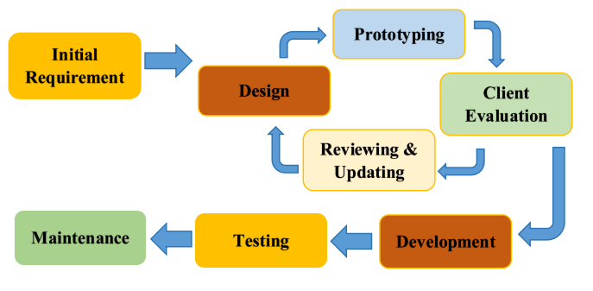

Figure 3.1: Software Engineering Methodology

The whole process from Prototyping up to Maintaining.
In the Analysis Phase, the researchers identified the objectives, scope, and system requirements of the proposed Eco Vision: Energy Efficient Street Lighting System with Sensor and Camera-Based Localized Crime Detection. Related literature and existing systems were reviewed to determine the project’s feasibility and establish the system’s functional and technical requirements. After that, the research team created a business model canvas of the system to ideate the proposed study. To validate the ideas, the research team did a face-to-face interview with the Police Office and Brgy, Cogon, Ormoc City.
During the Design phase, the research team developed the system architecture, circuit design, database structure and user interface. The sensor placement, camera integration and lighting control mechanism were designed to ensure efficient operation. System diagrams and prototypes were also prepared to guide the development process.
21
The actual programming effort starts during the implementation phase, when the previously documented planned system is turned into an actual system. The development of the code and database will enable the system’s functionality to be completed.
PLANNING AND IDEA CONCEPTION
This section presents the process by which the project is planned and conceptualized.
- Gantt Chart
A Gantt chart is a project management tool used to present the schedule of activities throughout the development of the proposed Eco Vision: Energy Efficient Street Lighting System with Sensor and Camera-Based Localize Crime Detection. It shows the sequence tasks, their corresponding start and end dates, and the duration of each activity. The Gantt chart enables the researchers to organize, monitor, and manage the project’s progress by ensuring that each task is completed within the allotted time. It also helps identify the task dependencies, maintain an organized workflow, and support the timely completion of the study.
TASK | START DATE | END DATE | DURATION
Planning | 01 - 15 - 2026 | 01 - 20 - 2026 | 5
Data Gathering | 02 - 11 - 2026 | 03 - 01 - 2026 | 18
Analysis | 03 - 02 - 2026 | 03 - 15 - 2026 | 13
Documentation | 01 - 25 - 2026 | 06 - 15 - 2026 | 141
Designing | 01 - 20 - 2026 | 01 - 25 - 2026 | 5
Prototyping  Table 3.1: Planning Tasks | 01 - 26 - 2026 | 03 - 01 - 2026 | 34  22
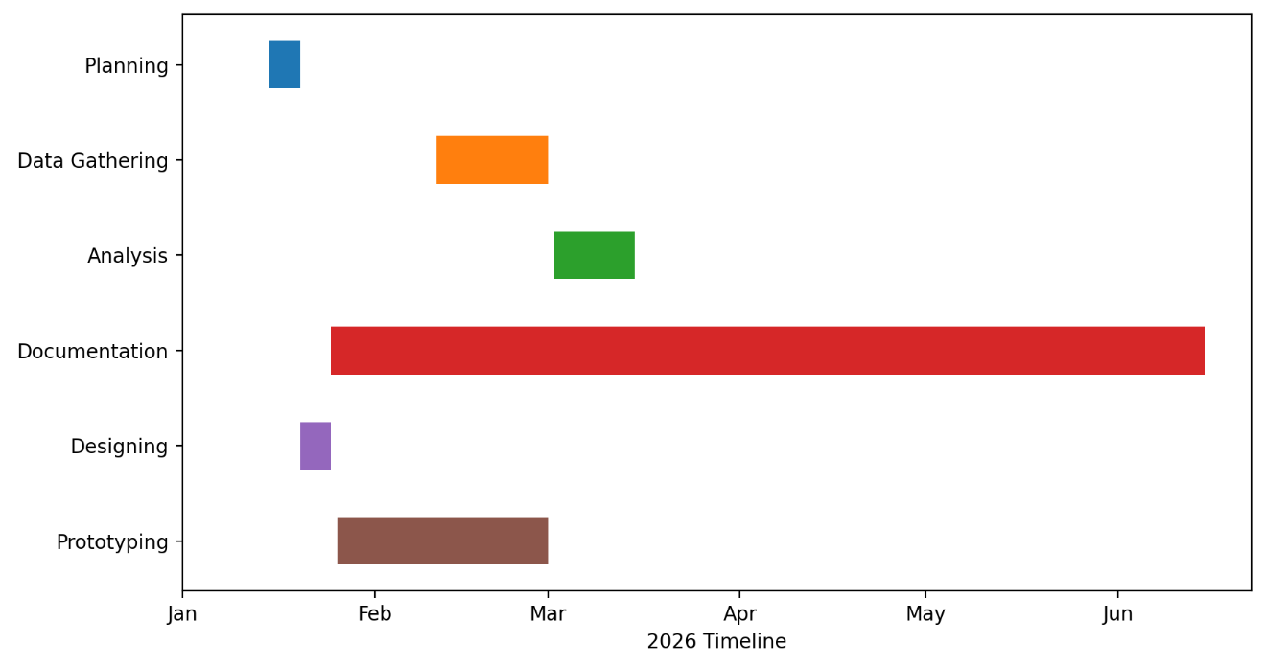
Figure 3.2: Gantt Chart
The figure above shows the schedule of each task needs to be accomplished by the researchers.
- Business Model Canvas
A Business Model Canvas is strategic management and lean startup for developing new or documenting existing business models. It is a visual chart with elements describing a firm’s value proposition, infrastructure and finances.
23

Figure 3.3: Business Model Canvas
This figure shows the different strategic management.
- Functional Decomposition
The Functional Decomposition Diagram (FDD) presents the Eco Vision: Energy Efficient Street Lighting System with Sensor and Camera-Based for localized Crime Detection as a structure in which overall system is divided into major functional components, with each component further decomposed into specific and independent sub-functions. This diagram illustrates how the system is organized into essential functions such as lighting control, image capture and processing crime detection, alert system, power management, data communication and system management. The Functional Decomposition Diagram provides a overview of the system’s functional requirements in each part of the system is intended to accomplish. This approach simplifies the analysis, design and development process by organizing complex system requirements into manageable and logically related functional areas.
24
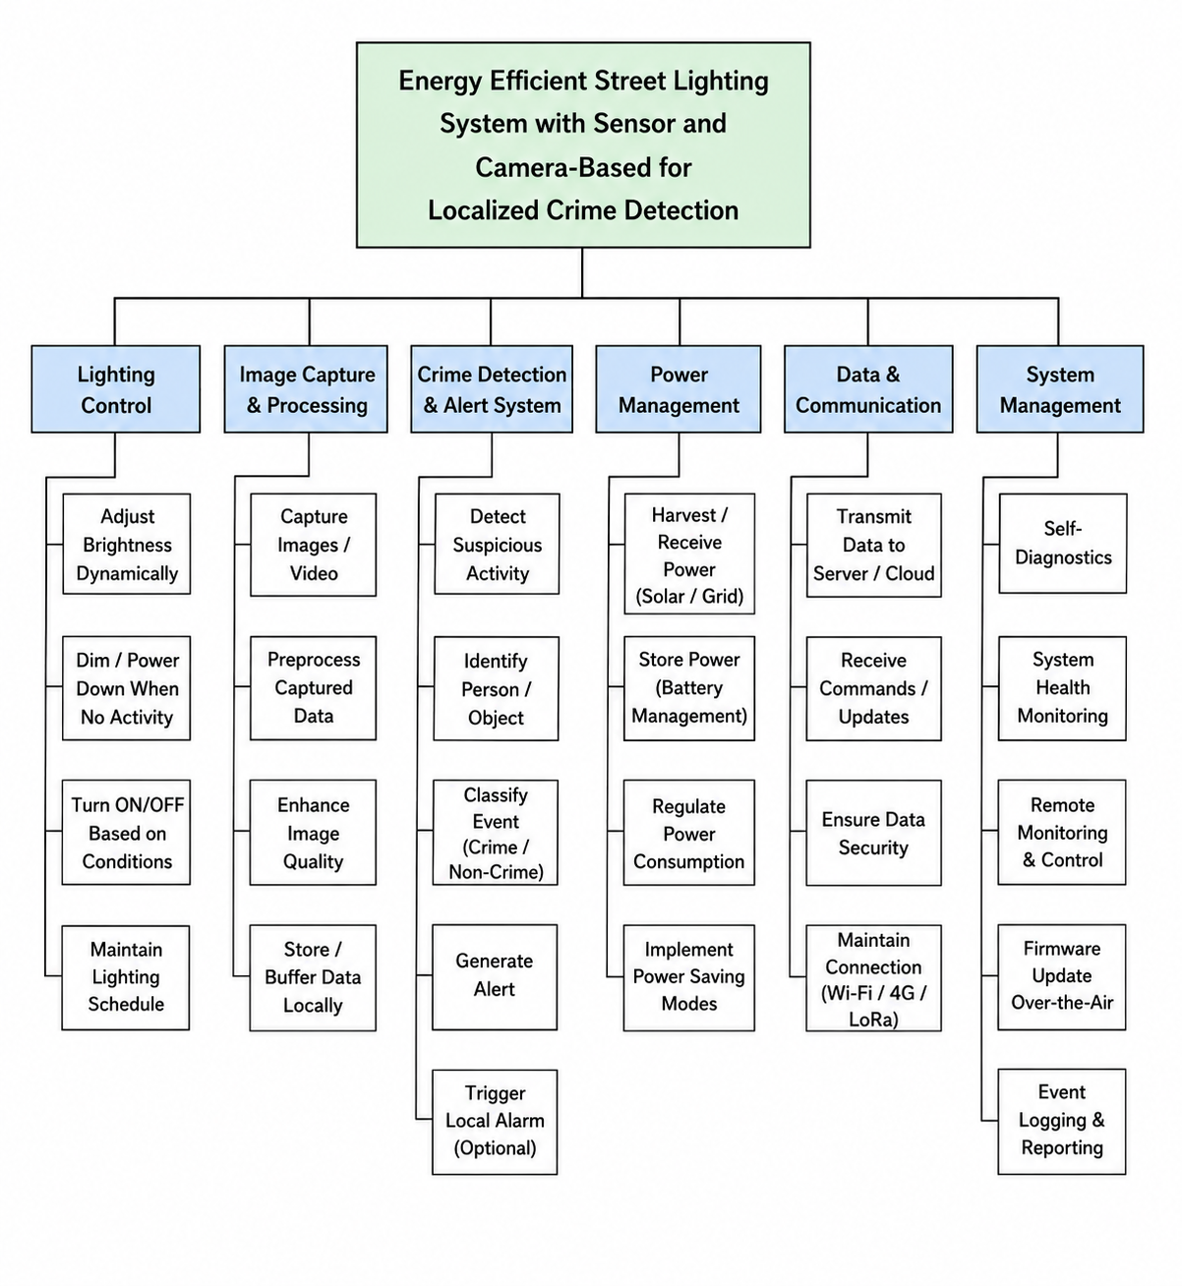

Figure 3.4: Functional Decomposition Diagram (FFD)

This figure above represents the work breakdown structure of the project.

25
- Conceptual Framework
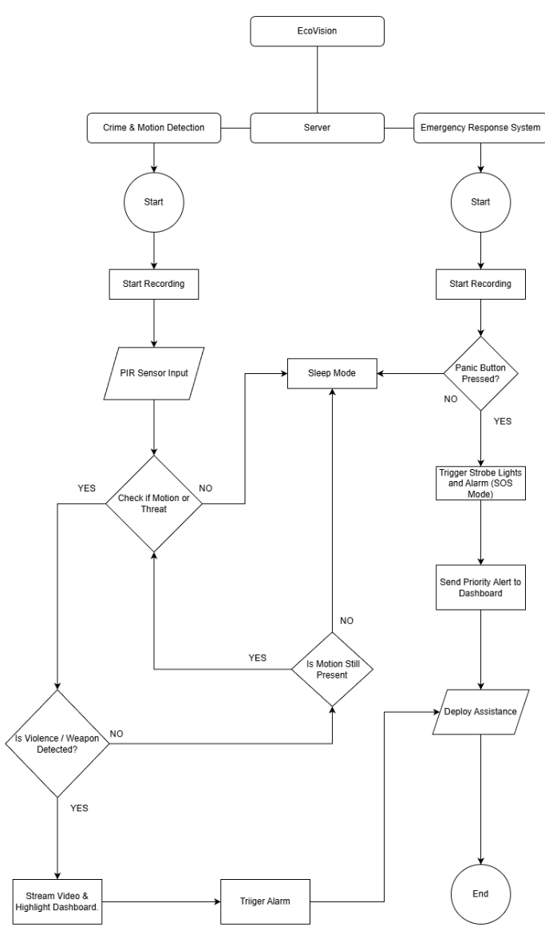

Figure 3.5: Conceptual Framework
26
ANALYSIS AND DESIGN PHASE
This section will elaborate on the process done during the analysis of the system.

- Use Case Diagram
The case diagram is a graphical depiction of a user’s possible interactions with a system. It consists of actors, use case and their relationship and used to model the system of a software/hardware.
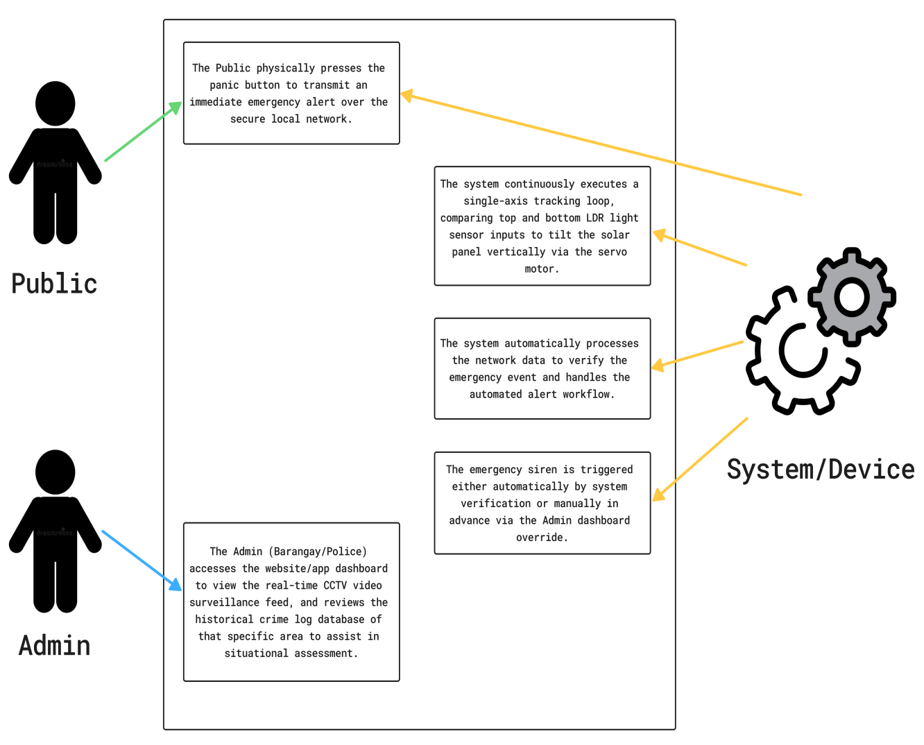

Figure 3.6: Use Case Diagram

A use case diagram looks something like a flowchart
27

- Prototype Design
This part presents the conceptualized model of the prototype designed by the researchers. The following discloses the needed and placement of each hardware components to be installed in Eco Vision: Energy Efficient Street lighting System with Sensor and Camera-Based for localize Crime Detection.

Figure 3.7: Prototype Design

28

DEVELOPMENT PHASE
This phase discusses the technologies that are utilized and how they are being integrated into the development and construction of the system.

- Software Development Specifications
The following are the software (system or application) used in the development of the project.

Arduino IDE

The Arduino IDE (Integrated Development Environment) is the official software used to write, compile, and upload code to microcontroller boards like the Arduino Uno, ESP32, etc. It acts as the bridge between your human-readable instructions and the raw hardware, providing a simplified interface that handles the complex background tasks of translating code into electrical signals.
Figure 3:8: Arduino IDE

SketchUp

SketchUp functions as the primary 3D Modeling and CAD (Computer-Aided Design) software. While the Arduino IDE handles the "thinking," SketchUp is used to design the "body" of the machine. It allows you to create a virtual 3D blueprint of the entire system before any physical parts are cut or 3D printed.
Figure 3.9: SketchUP

29
Fritzing

Fritzing is a primary electronic circuit design and prototyping software for a project. It is used to create a circuit schematics, breadboard layouts, and writing diagrams that illustrate the connections between electronic component. It provides visual presentation of the systems' electrical design.
Figure 3.10: Fritzing

Proteus 8

Proteus 8 is a circuit simulation and electronic design software for a project. It is used to design, simulate and test electronic circuits before the physical implementation. This software Proteus 8 allows the developers to analyze the electronic circuits performance and behavior.
Figure 3.11: Proteus 8
Fusion 360

Fusion 360 is primarily functions as a computer-aided design (CAD) and 3D modeling software for a project. It is used to create digital detailed models of a system structural framework. This software allows the designers to visualize the overall design by providing accurate modeling and design tools.
Figure 3.12: Fusion 360
30
ARTIFICIAL INTELLIGENCE (AI) DEVELOPMENT
Roboflow

Roboflow primarily functions as the dataset management and computer vision development. This software is used to collect, label, organize and preprocess the images data for training object detection and classification models.
Figure 3.13: Roboflow


Visual Studio Code
Visual Studio Code primarily functions as a code development programming environment. This software is used to manage source code system, write and edit. Visual Studio Code supports multiple programming languages and features for debugging tools and syntax highlighting.
Figure 3.14: Visual Studio Code
AutoCAD

AutoCAD primarily function as a computer-aided design (CAD) software that is used for creating 2D Drawing and 3d models. This software used usually for Engineers, Architects and Design to draft. AutoCAD supports for design tools and features, including technical drawing.
Figure 3.15: AutoCAD
31
Microsoft Office Word

Microsoft Office Word used for making the entire documentation of the said project.

Figure 3.16: Microsoft Office Word

Microsoft Office Power Point

Microsoft Office Power Point used for making presentations of the said project.

Figure 3.17: Microsoft Office Power
Point

32
DATASET DEVELOPMENT AND MODEL TRAINING
A. Dataset Composition
The violence classifier was trained on clips assembled from four public datasets and from footage captured by the researchers from live Philippine street cameras. The composition of the final dataset is given below.
Source | Type | Role
RWF-2000 | Benchmark surveillance violence | Positives and negatives
SCVD | Smart-city violence, includes weapons | Positives and negatives
CCTV-Fights (CCTV) | Real fixed-camera CCTV fights | Positives and negatives
CCTV-Fights (non-CCTV) | Handheld and vehicle footage | Positives and negatives
UCF-Crime | Real continuous surveillance | Normals only
Philippine live captures | Davao street CCTV, day and night | Negatives only
Table 3.2: Dataset Sources
Final composition after filtering:
Split | Clips | Violent | Normal
Train | 7,630 | 2,805 | 4,825
Validation | 1,164 | 582 | 582
Test | 1,180 | 590 | 590
Table 3.3: Dataset Split Composition
UCF-Crime's violent classes were deliberately excluded. Manual review of the extracted clips found that approximately 96 percent of its violence categories are filmed indoors, in shops, garages, metro stations and corridors, while its normal category is roughly 57 percent outdoor street. Training on both would offer the model a shortcut it would be expected to take, namely that indoor implies violent. For a system whose deployment target is an outdoor streetlight, that association would make outdoor violence harder to separate rather than easier. The normal clips were retained because 900 clips of real continuous outdoor surveillance containing no incident are directly useful as negative examples.
B. Data Integrity Procedures
Three verification procedures were applied, each because an error of that kind was found in practice during development. First, decode validation: clips were confirmed to contain readable frames after extraction, because the ffmpeg utility returns a success code when a requested segment begins past the end of a source video, producing a valid file containing zero frames. Three such files were found and quarantined. Second, motion filtering: 378 clips labelled violent were found to contain almost no inter-frame motion, showing empty car parks and static scenes, and were excluded, since a motionless clip labelled violent teaches the model that stillness indicates violence. Third, visual review: every extracted dataset was rendered as a contact sheet and inspected before training, and label directories were not trusted. This procedure is what identified the UCF-Crime indoor bias described above.
C. Split Methodology and Leakage Prevention
Splits are assigned by content hash rather than random shuffle, so that byte-identical duplicate clips cannot land on opposite sides of the training and test boundary. Content hashing alone is insufficient once clips are cut from longer source videos, because two clips from the same source have different bytes but show the same camera, scene and people. Clips are therefore grouped by source video and by physical camera, and an entire group is assigned to a single split. Without this, a test set can contain a camera the model trained on and appear independent while in fact measuring memorisation.
Three cameras, namely Agdao Market, Agdao Bus Stop and Flyover, and the camera outside Lyn's Restaurant, were designated validation-only and excluded from every training manifest by construction. All false-alarm figures reported in Chapter 4 are measured on these cameras.
D. Model Configuration
The classifier is an X3D-XS network initialized from Kinetics-400 pretrained weights, accepting 13 frames at 160 by 160 pixels covering the whole frame. Of its 2,978,772 parameters, 1,920,794 are trainable. Training uses negative log-likelihood loss on log-softmax outputs, with a zoom-out augmentation applied to 45 percent of clips at scales between 0.18 and 0.9 of original size. All training was performed on a single NVIDIA GTX 1660 SUPER with 6 GB of memory. The zoom-out augmentation exists because a wide street camera places a person at a much smaller fraction of frame height than benchmark footage does; its effect is measured in Chapter 4.
E. Evaluation Metrics
Four metrics are reported. Recall is the proportion of violent clips detected, and is weighted heavily because a missed assault is the costlier error for a public safety system. False-positive rate is the proportion of normal clips wrongly flagged. Precision is the proportion of alarms that were correct. False alarms per hour is the number of alarms raised per hour of continuous footage containing no incident. The last metric is reported because clip-level false-positive rate structurally understates a camera that runs continuously, and Chapter 4 demonstrates that the two do not track each other.
F. Weapon and Sign Detector Dataset
Weapon and sign detection uses a separate YOLO object-detection model, trained independently from the three detectors described above (violence, robbery, vandalism). Its training images and weapon/sign labels were assembled from seven public datasets hosted on Roboflow Universe, the dataset labelling and management platform introduced earlier in this chapter (AI Development, Section 3.4). Table 3.2b lists all seven; full citations follow the table.
Table 3.2b: Weapon and Sign Dataset Sources
Dataset | Owner | Images | Licence
Gun-cctv-detection | dietest | 5,149 | CC BY 4.0
Gun detection | workspace-1qko2 | 36,105 | Public Domain
Gun and knife detection | Mahad Ahmed | 8,451 | CC BY 4.0
Knife | Sanket Kulkarni | 7,073 | CC BY 4.0
Knife-dataset | workspace-zqssx | 4,075 | CC BY 4.0
Traffic and Road Signs | Usman Chaudhry | 10,000 | CC BY 4.0
CCTV Knife Detection Dataset (synthetic, sample) | Simuletic | 114 | CC BY 4.0
The synthetic dataset (Simuletic) is a 114-image sample of a larger, non-public dataset; it is included for the diversity of its synthetic CCTV-angle knife imagery, not as a primary source. All other datasets contain real photographs. Class labels vary by source (handguns, rifles, knives, and traffic/road signs, the last of which supports the sign component of the weapon-and-sign detector) and were consolidated during preprocessing.
Dataset Citations
dietest. (2023). Gun-cctv-detection (Version 1) [Data set]. Roboflow. https://universe.roboflow.com/dietest/gun-cctv-detection
workspace-1qko2. (2024). gun detection (Version 4) [Data set]. Roboflow. https://universe.roboflow.com/workspace-1qko2/gun-detection-ghlzd
Ahmed, M. (2022). gun and knife detection (Version 1) [Data set]. Roboflow. https://universe.roboflow.com/mahad-ahmed/gun-and-knife-detection
Kulkarni, S. (2022). knife (Version 1) [Data set]. Roboflow. https://universe.roboflow.com/sanket-kulkarni/knife-eydvx
workspace-zqssx. (2022). knife-dataset (Version 2) [Data set]. Roboflow. https://universe.roboflow.com/workspace-zqssx/knife-dataset-4kytl
Chaudhry, U. (2022). Traffic and Road Signs (Version 1) [Data set]. Roboflow. https://universe.roboflow.com/usmanchaudhry622-gmail-com/traffic-and-road-signs
Simuletic. (2025). CCTV Knife Detection Dataset (Sample Version) (Version 1) [Data set]. Roboflow. https://universe.roboflow.com/simuletic/cctv-knife-detection-dataset-zkkaf
These entries follow Roboflow's own recommended data-set citation format and should be carried into a References/Bibliography chapter if and when one is added to this manuscript (see note in Chapter II).
- Hardware Development Specifications
The following are the hardware units or components used in the development of the project.
POLE SYSTEM
ESP32 Microcontroller
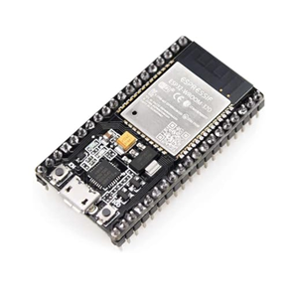
The ESP32 serves as a micro controller of Energy-Efficient Street Lighting System with Sensor and Camera-Based Localized Crime Detection. The ESP32 is responsible for collecting the data from the sensors such as controlling brightness of the street light, inputs of camera, and managing the wireless communication. ESP32 allow real-time monitoring and automation by activating the streetlights when there is motion detected, which alerts the authorities.
Figure 3.18: ESP32
Microcontroller

Siren
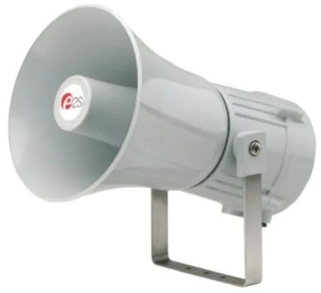
Siren is an electronic warning device within the Energy-Efficient Street Lighting System with Sensor and Camera-Based Localized Crime Detection that can produces loud sound to alert the people around the area to emergencies and any possible incidents that happen. When the camera and sensors detect suspicious activities, potential crime behavior or incidents, the siren alert the people in the area and deter possible offenders. The siren providing a response mechanism that complements the surveillance system.
Figure 3.19: Siren
33

Button
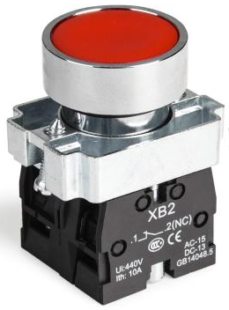
A button is a manual input device that is used for activating a specific functions in a system. In the Energy-Efficient Street Lighting System with Sensor and Camera-Based Localized Crime Detection, it serves as one of emergency trigger that send a signal to ESP32 by activating the siren, streetlight brightness and alert the authorities or people in the area if there is suspicious activities, incidents or emergencies.
Figure 3.20: Button
LiFePO4 Battery (12V 50Ah)
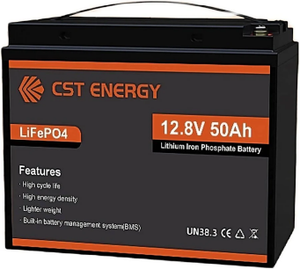
A LiFePO4 Battery (12V 50Ah) serves as a power source of the Energy-Efficient Street Lighting System with Sensor and Camera-Based Localized Crime Detection. it provides a stable supple energy for the components that used in the pole. Due to long lifespan and high efficiency. The LiFePO4 Battery support all the system operation while promoting a sustainable performance and energy-efficient.
Figure 3.21: LiFePO4
Battery

Relay Module
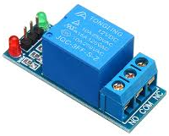
A relay module is an electronic switching device that enable ESP32 by controlling high-power components using a low voltage signals. In the Energy-Efficient Street Lighting System with Sensor and Camera-Based Localized Crime Detection, the purpose of relay module is used for streetlights, siren and other devices to switch on and off based on a sensor inputs and a system commands. This devices allows efficient power management and automated operation of a system.
Figure 3.22: Relay
Module
34
Optocoupler Isolation Module
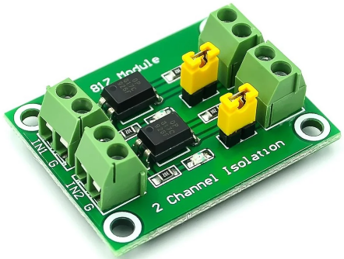
An Optocoupler Isolation Module is a protective components used in electrically that isolate the low-voltage and high-voltage devices in a system. In the Energy-Efficient Street Lighting System with Sensor and Camera-Based Localized Crime Detection, it used for ESP32, relay and streetlights in order to prevent voltage spikes from damaging the micro-controller. This Optocoupler Isolation Module ensures safe, stable and reliable operation of the entire system.
Figure 3.23: Optocoupler
Isolation Module
LM2596 Buck Converter
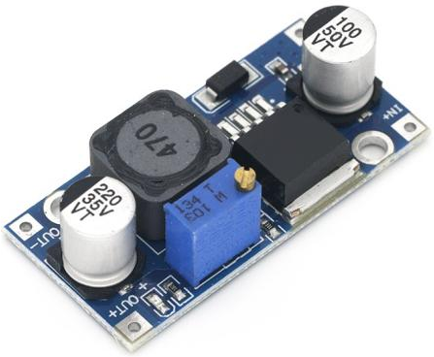
A LM2596 Buck Converter is a voltage regulator module that is used to lower down the higher DC voltage to a lower and stable voltage. In Energy-Efficient Street Lighting System with Sensor and Camera-Based Localized Crime Detection, it is used for supply and regulated voltage to lower a power components including the ESP32, sensors and camera from the main power supply which is the battery source. This LM2596 Buck Converter helps the power management and prevents a voltage damage.
Figure 3.24: LM2596
Buck Converter

Solar Charger
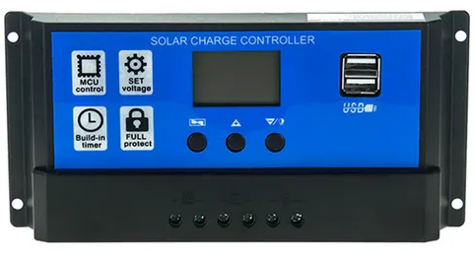
A Solar Charger is renewable energy components used to convert sunlight into electrical energy for charging the system battery. In Energy-Efficient Street Lighting System with Sensor and Camera-Based Localized Crime Detection, it supplies a power into the LiFePO4 Battery, by ensuring a continuous operation of all the electronic devices. By this Solar Charger it utilize solar energy, reduces dependence on electrical grid and support long-term energy efficiency.
Figure 3.25: Solar Charger
35
Buck Boost Converter
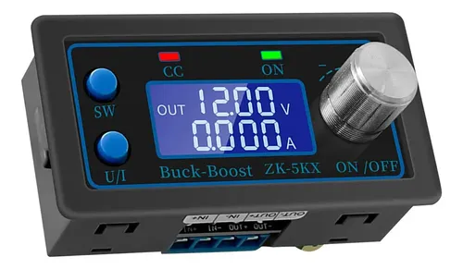
A Buck Boost Converter is a DC-DC voltage regulator that can step up or or step down a DC input in order to maintain a stable output voltage. In Energy Efficient Street Lighting System with Sensor and Camera-Based Localized Crime Detection, it supplies regulated power to the other components such as ESP32, sensors and other components needed from the battery source. This component ensures a stable operation despite voltage fluctuations and helps to prevent damage to the other sensitive components
Figure 3.26: Buck Boost Converter

SOLAR TRACKER
Solar Panel
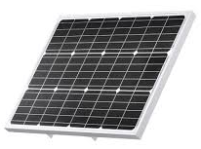
A Solar Panel is a renewable energy device that converts sunlight into electrical energy through s photovoltaic cells. In the Energy-Efficient Street Lighting System with Sensor and Camera-Based Localized Crime Detection, the solar panel is used to harvest solar energy and supply to the LifePO4 Battery by ensuring a continuous and sustainable operation of other electrical devices and by this it ensures utilizing power and energy-efficient.
Figure 3.27: Solar Panel
36
Light Dependant Resistor
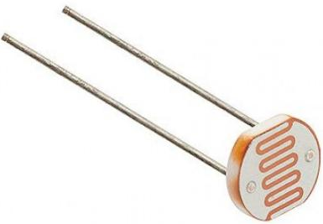
A Light Dependent Resistor (LDR) serves as a light-sensing component of Solar Tracker in the proposed research Energy-Efficient Street Lighting System with Sensor and Camera-Based Localized Crime Detection. The Light Dependent Resistor is a responsible for detecting intensity and direction of a sunlight by measuring the ambient light. The data that is collected from the LDR component is transmitted to the ESP32, that process the optimal position of a solar tracker. This component allows the solar tracker to automatically adjust a panel's position throughout the day.
Figure 3.28: Light Dependant
Resistor

LIGHT
Solar Street Light
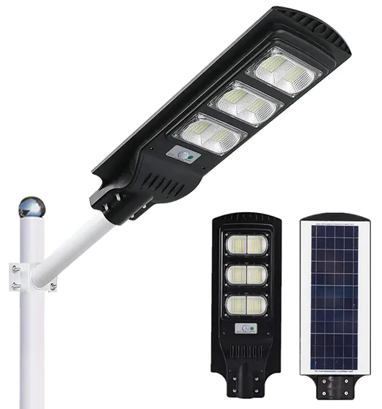
A Solar Street Light is a primary illumination component. In the Energy-Efficient Street Lighting System with Sensor and Camera-Based Localized Crime Detection, a solar street light is responsible for providing enough lighting for the public areas using only a stored energy from a solar power. This component operates automatically based from the commands of the ESP32 and other sensor inputs, brightness adjusting based on the environment conditions and the detected activities around the area. This allows energy efficiency enhancement and improve visibility during night time.
Figure 3.29: Solar
Street Light
37

TESTING PHASE
This part shows what the proponents did during the testing stage in every hardware and software used and when these units were integrated already.
Unit Testing
During the unit testing, the proponents tested the hardware components and website, both with or without programming, executing their designated functions separately to check if they performed accordingly.
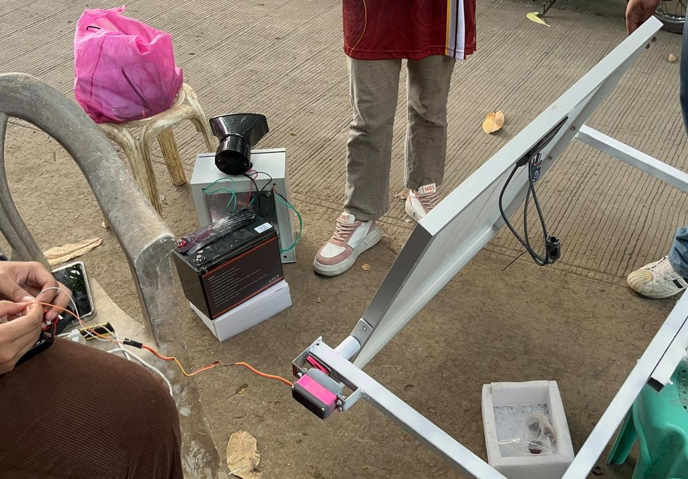

Figure 3.30: Solar Panel Test

The Servo, Solar Panel and Battery was tested at home.

38
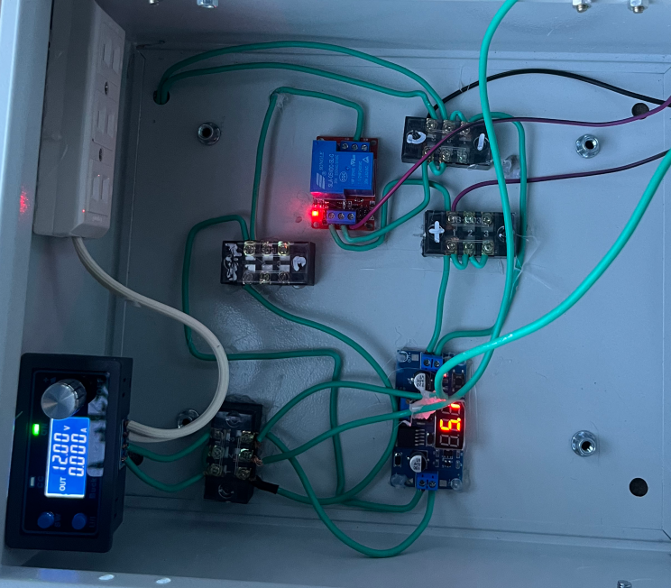

Figure 3.31: Buck Boost Converter and Buck Converter Test

We tested the performance of the Buck Boost Converter and Buck Converter to ensure stable and regulated power distribution within the system.
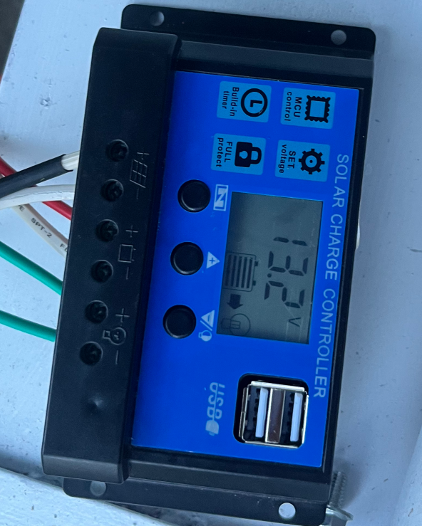

39
Figure 3.32: Solar Charger Test

We tested the performance of the Solar Charger to ensure the efficient battery charging.
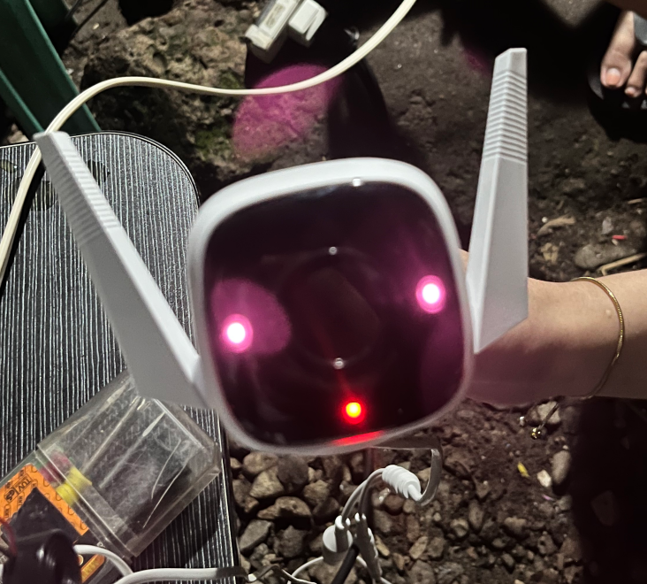

Figure 3.33: CCTV Camera Tesst

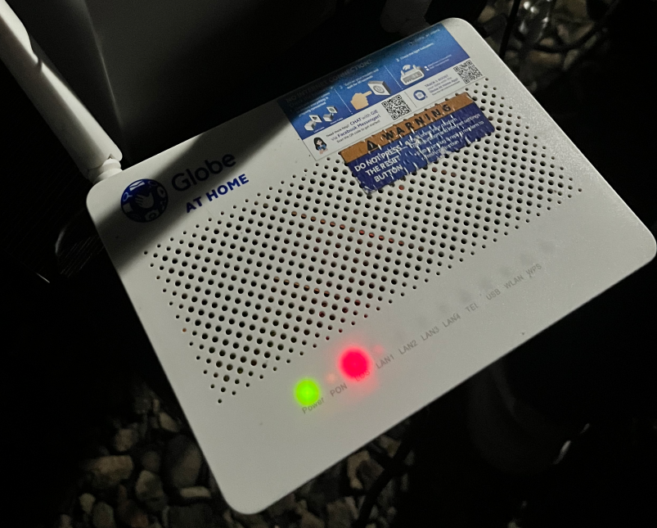
We tested the functionality of CCTV Camera to ensure it operates properly.

40
Figure 3.34: WiFi Test

We tested the functionality of WiFi to ensure it functions and maintains a stable network connection.

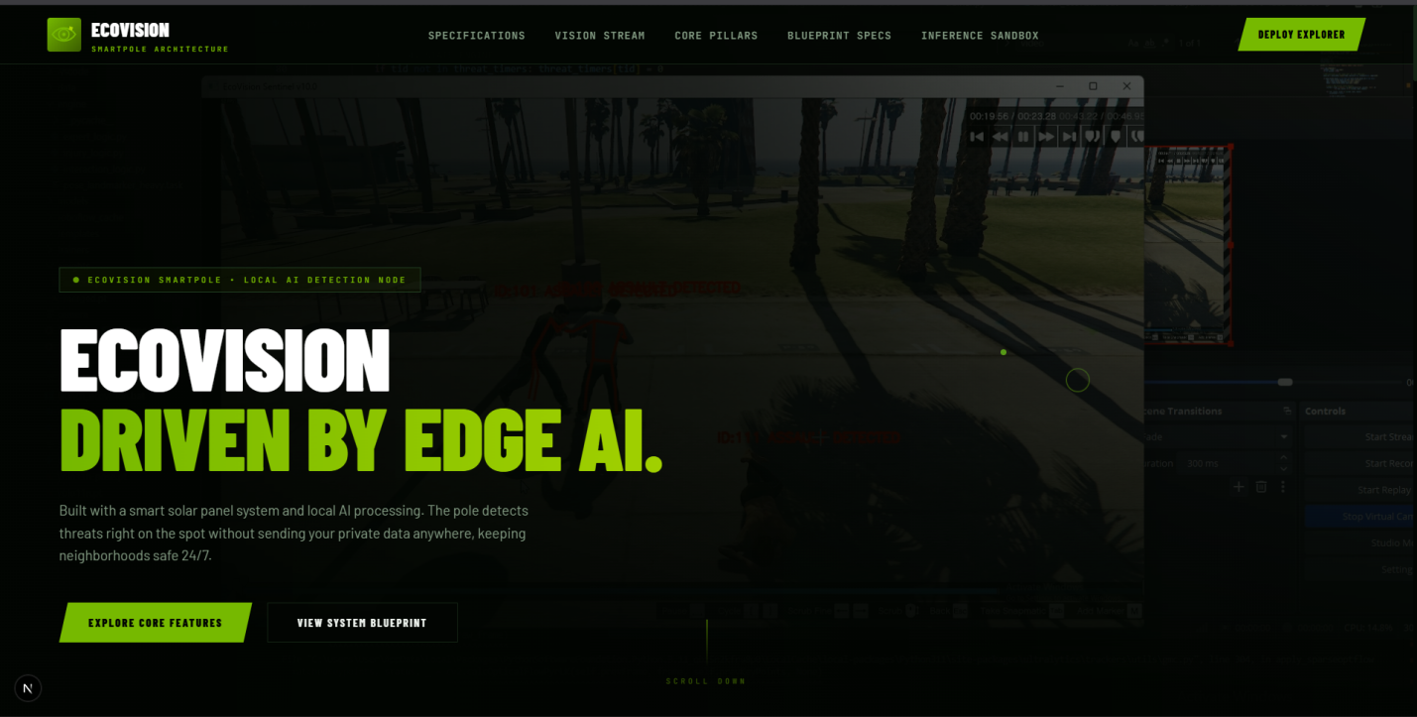

Figure 3.35: Home Page Test


We tested the performance of the homepage from the system’s customized link to ensure it correctly loads. Displaying the Home Page of our website.

Figure 3.36: About Us

When exploring further, we include about us feature that provides in-depth insights into the system and its team.
41

FINDINGS AND CONCLUSIONS

4.1 Detection Accuracy on Held-Out Data
The current model was evaluated on 932 clips present in the test split of both the previous and current dataset manifests and in the training split of neither. This is the only set on which two model versions can be compared without one of them having seen the data.
Metric | Previous model | Current model
Recall | 87.1% | 91.4%
False-positive rate | 13.5% | 12.9%
Precision | 91.8% | 92.5%
Accuracy | 86.9% | 89.8%
Table 4.1: Detection Accuracy on 932 Held-Out Clips
The improvement holds across the operating range rather than at a single threshold. At a matched recall of 84.6 percent, the previous model requires an 11.4 percent false-positive rate while the current model achieves the same recall at 8.2 percent. The only difference between the two models is the training negatives: 3,925 clips drawn from 7 daytime cameras against 4,825 drawn from 26. Architecture, initialization and positive examples are identical.
It should be noted that this is one training run compared against one training run, without repetition across random seeds. The direction is supported by two independent measurements, namely benchmark clips and continuous footage, but the 4.3-point recall improvement should be read as a direction rather than a precise quantity.
4.2 False Alarms on Real Philippine Street Cameras
False alarms were measured on three cameras excluded from all training data, for 20 minutes each, at identical settings.
Camera | Previous model | Current model
Agdao Bus Stop / Flyover | 93 / hr | 84 / hr
Agdao Market | 15 / hr | 3 / hr
Outside Lyn's Restaurant | 15 / hr | 9 / hr
Total | 41 / hr | 32 / hr
Table 4.2: False Alarms per Hour on Held-Out Cameras
The reduction is uneven, and the unevenness is itself the finding. The market camera improved five-fold while the flyover camera barely moved. This is examined in section 4.6.
4.3 Effect of Scale Augmentation on Wide-Camera Detection
The project's initial architecture study identified a failure mode described as deployment-blocking. Replaying clips that the model detected with full confidence while progressively shrinking the people in them produced 40 detections out of 40 at 37 percent person height and zero out of 40 at 9 percent, the range typical of a wide street camera. The model was not less confident at small scale; it was blind. The same measurement was repeated on the current model, which was trained with zoom-out augmentation.
Person height in frame | ~37% | ~13% | ~9%
Earlier checkpoint | 40/40 | not measured | 0/40
Deployed model | 85.4% | 80.9% | 71.9%
Table 4.3: Recall Against Person Size in Frame
Degradation is now gradual rather than a cliff. The failure was closed in the training data rather than in the architecture, which is the more economical solution: the alternative under consideration, tiled multi-region inference, costs approximately eight times the computation per frame.
4.4 Negative Result: Pose-Derived Filtering
Four filters were implemented from YOLO pose output and evaluated on 60 minutes of held-out camera footage together with 89 violent clips. Each is compared against the alarm rate that a plain threshold adjustment achieves at the same recall.
Filter | Alarms/hr | Recall | Threshold alone, same recall
None | 63.0 | 85.4% | -
At least 1 person present | 57.0 | 68.5% | 20.0
At least 2 people in proximity | 54.0 | 55.1% | 8.0
Wrist velocity above threshold | 8.0 | 37.1% | 0.0
Motion localised in person boxes | 15.0 | 34.8% | 0.0
Table 4.4: Pose-Derived Filters Compared Against Threshold Adjustment
No filter performs better than the threshold. The wrist-velocity filter reduces false alarms by 87 percent, which appears successful until recall is read alongside it, falling from 85.4 percent to 37.1 percent. Raising the threshold to 0.90 achieves one alarm per hour at 50.6 percent recall, which is superior on both axes, with no pose model and no additional per-frame computation.
The diagnosis of one filter is worth recording. Motion localisation was found to correlate with the number of people in frame rather than with the source of the motion, with median localisation rising from 0.000 with no people present, to 0.104 with two or three, to 0.644 with eight or more. The measure therefore reports low values on wide cameras where people are small, which are precisely the cameras it was intended to assist.
4.5 Negative Result: Tiled Inference
Tiled inference divides the frame into overlapping regions, each classified independently, and raises an alarm if any region does. It was expected to assist wide cameras by restoring apparent person size. At equal recall of 85.4 percent, whole-frame inference at threshold 0.55 produces 42 alarms per hour while tiled inference at threshold 0.75 produces 211, for roughly eight times the computation. With ten regions evaluated per check, the system has ten independent opportunities to be wrong, and the false-alarm cost outweighs the recall benefit at every setting tested.
The earlier evidence favouring tiling had measured recall only. This suggests a general caution: a change that increases detections must be evaluated on false alarms, and a change that reduces false alarms must be evaluated on recall. Measuring one alone guarantees a favourable answer.
4.6 Benchmark Accuracy Does Not Predict Field Performance
Three model checkpoints were compared on both a benchmark test split and real continuous footage.
Checkpoint | Benchmark FPR | Real camera alarms/hr
Baseline | 11.2% | 54.0
Plus real-CCTV negatives | 11.4% | 26.0
Plus motion filtering | 10.7% | 4.0
Table 4.5: Benchmark False-Positive Rate Against Real-Camera Alarm Rate
Benchmark false-positive rates are indistinguishable while real alarm rates differ by a factor of 13.5. Had this work relied on the test split alone, which is the conventional approach, the largest false-alarm improvement of the project would have registered as no change at all.
The cause is domain rather than statistics. Benchmark negatives are curated, framed, and largely indoor or close-range, while Philippine street surveillance at night is none of these. A model can be excellent at rejecting the first and poor at the second, and a clip-level rate computed on curated data cannot distinguish the two cases. This is offered as a methodological finding: benchmark false-positive rate should not be used as a proxy for false alarms per hour on a deployed camera.
4.7 False Alarms Are Camera-Specific
Running the current detector across 253 minutes of newly captured daytime footage from 14 street cameras produced almost no false alarms. Twelve of the fourteen cameras produced zero in 20 minutes each, and the remaining two produced one and two respectively. On the same day, at the same settings, the flyover camera produced 84 per hour.
The false-alarm problem is therefore concentrated in specific camera installations rather than distributed across the system or attributable to time of day. Four candidate explanations for the flyover camera were tested and rejected: small person scale, which was ruled out by the 71.9 percent recall measured at that scale; high global scene motion, motion blur, and camera pan and zoom, each of which was found to be depleted rather than enriched among alarms, at 0.6, 0.4 and 0.6 times chance respectively. Alarms therefore occur on clear, sharp, stationary-camera frames. The remaining explanation is that the model finds ordinary night bus-stop and roadside traffic activity genuinely similar to violence, which is a training data coverage problem rather than an image quality one.
4.8 Operating Point Selection
Because both error types carry real cost, the operating point was selected from a measured curve rather than assumed. Raising the confidence threshold from 0.50 to 0.55 removes a third of all false alarms at no cost in recall, with 63 alarms per hour falling to 42 while the same 76 of 89 clips are detected at both settings.
Per-camera calibration was also evaluated, with each camera's threshold set from a percentile of its own quiet footage and validated on a later segment it had not seen. This reduced the three-camera total from 46 to 20 alarms per hour, and its advantage grows with network size, because quiet cameras remain at the minimum threshold and retain full recall while only busy cameras pay. For a pole-mounted deployment this is a practical commissioning step: record a few quiet minutes at the camera's final angle, compute one value, and record it.
4.9 Conclusions
First, a three-dimensional convolutional network detects violence in Philippine street surveillance footage at 91.4 percent recall and 12.9 percent false-positive rate on held-out data, running on a single consumer graphics processor.
Second, detection accuracy is governed principally by the representativeness of the training negatives. Every inference-time intervention tested, including four pose filters, tiled inference and persistence requirements, was outperformed by adjusting the confidence threshold, while both interventions that improved the system materially were additions of locally-captured negative footage.
Third, clip-level benchmark metrics do not predict false alarms on a continuously-running camera and should not be reported alone for systems of this type.
Fourth, false-alarm behaviour is a property of the individual camera installation. Per-camera calibration is more effective than a single system-wide threshold and is practical as an installation step.
Fifth, scale augmentation during training removes the wide-camera blindness that would otherwise require substantially more expensive tiled inference.
Sixth, a second model that checks each alarm allows the first-stage detectors to run looser, and the combination outperformed the detectors alone: 94.0 percent of fights caught at 0.4 false alarms per hour against 88.0 percent at 1.4, and 59.4 percent of robbery events labelled correctly against 8.3 percent (section 4.14). The check needs memory that the smallest target machines may lack; it then runs on the processor, or switches off and the system returns to its first-stage settings.
Seventh, five hours of camera footage gives only one to fourteen alarms per setting, so the false-alarm reductions are not individually statistically significant. The recall gains are better supported, and recall on the deployment cameras is still unmeasured.
4.10 Recommendations for Future Work
The most significant remaining gap is the absence of labelled violent incidents from the deployment cameras. Recall is currently validated entirely on foreign benchmark footage, so no recall figure specific to Philippine street conditions can be stated. Even a few dozen verified incidents, whether barangay-reported, retrieved from archived footage, or staged under controlled conditions, would change what can be claimed.
Robbery and vandalism have been trained as classifiers since the August measurements, but both remain experimental. Vandalism rests on 31 test acts from few source videos, and a larger, more varied set of filmed examples is the main lever for improving it.
Training should be augmented with synthetic camera motion so that the model becomes invariant to pan and zoom, rather than filtering such frames at inference time.
Person-crop inference should be evaluated for multi-camera scaling. Running inference only where people are detected would allow an idle scene to cost nothing, which is the principal barrier to serving multiple cameras from one processing unit.
4.11 Confusion Matrix Results for All Three Detectors
Sections 4.1 through 4.10 summarise performance as percentages, such as recall and false-positive rate. This section shows the raw counts behind those percentages -- how many clips were correctly flagged, how many were missed, and how many false alarms were raised -- for all three detectors, not only violence. Every figure comes from running the same detection code the app actually uses, scoring one prediction per clip, at the exact confidence threshold each detector is currently set to. All figures are measured on each detector's held-out test clips: footage set aside and never used for training or for choosing the final model.
Detector | Threshold | TP | FP | TN | FN | N | Accuracy
Violence | 0.5 | 549 | 24 | 631 | 106 | 1310 | 90.1%
Robbery | 0.7 | 32 | 5 | 85 | 17 | 139 | 84.2%
Vandalism | 0.9 | 22 | 3 | 5 | 7 | 37 | 73.0%
Table 4.6: Confusion Matrix Counts at Current Threshold Settings
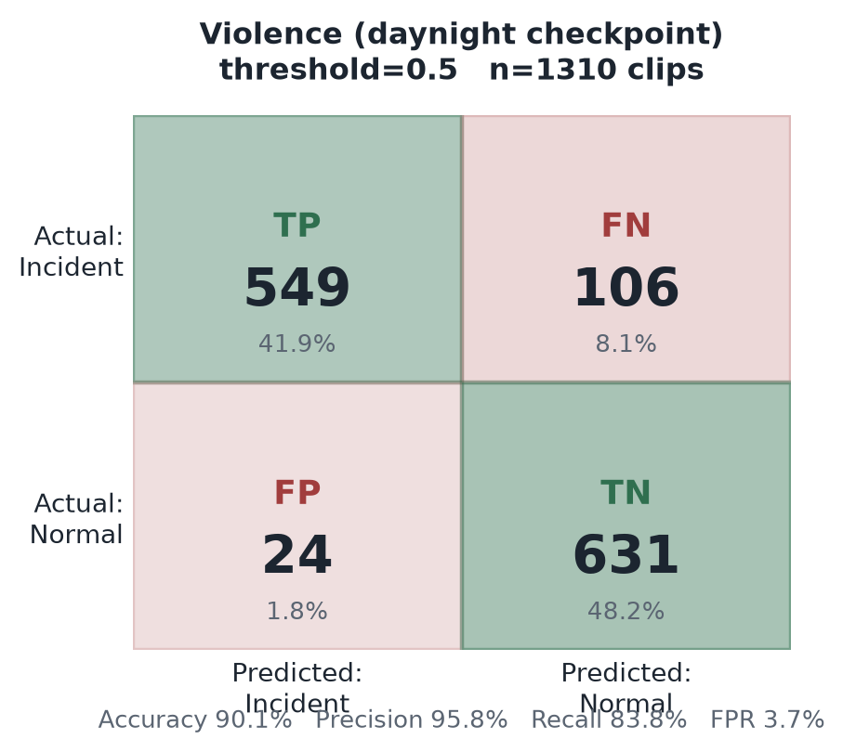 | 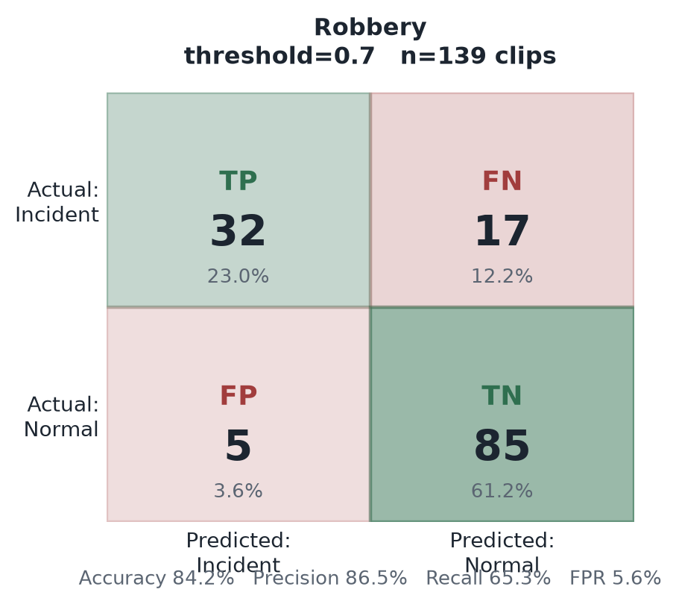 | 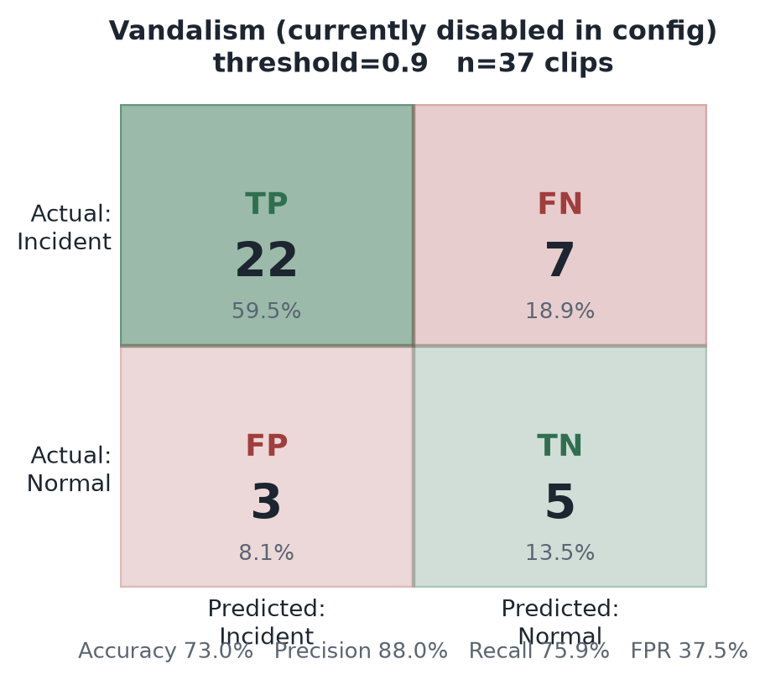
Figure 4.11a-c: Confusion Matrices — Violence (day-and-night model), Robbery, Vandalism
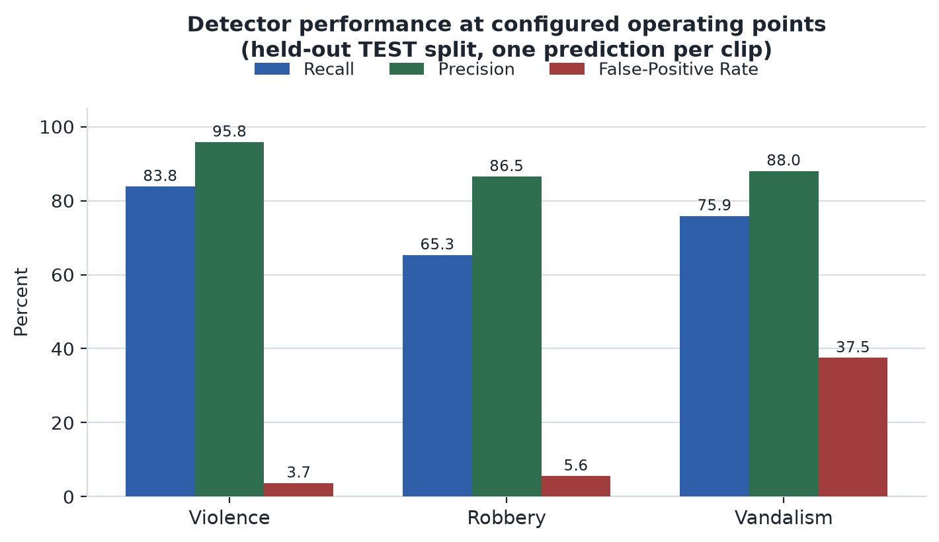
Figure 4.11d: Recall, Precision and False-Positive Rate by Detector
Violence detection is the most mature of the three: 90.1 percent accuracy with a 3.7 percent false-positive rate on 1,310 test clips, the model discussed throughout this chapter. Robbery reaches 86.5 percent precision but only 65.3 percent recall on a much smaller test set of 139 clips, consistent with training on the smaller labelled corpus available for that category (Chapter III, Dataset Development). Vandalism's figures -- 75.9 percent recall but a 37.5 percent false-positive rate -- should be read with the same caution given to any measurement on 37 test clips: a single misclassified clip moves the reported rate by roughly 2.7 percentage points, so this is a noisy estimate rather than a settled result. This is exactly why vandalism detection currently ships turned off, rather than being presented as validated to the same standard as violence and robbery -- a deliberate scope decision recorded in Section 4.10, not an oversight. None of the three figures reported in this section are field-validated: all were measured on held-out benchmark and evaluation footage, not on incidents observed through an installed, operating system.
4.12 Detection Architecture: The Per-Frame Pipeline
Every camera frame passes through the same fixed pipeline. A pose-detection model (YOLO11s-pose) first locates people and their body position in the frame. Violence, robbery and vandalism are not three unrelated models bolted together -- they share one underlying detector design, trained separately for each category with its own confidence threshold and its own requirement for how many frames in a row must look suspicious before anything is confirmed. Each detector's raw confidence for the current frame is smoothed: instead of reacting to a single lucky or unlucky frame, the system averages recent frames, weighting the most recent ones more heavily, and only confirms an incident once several frames in a row clear the threshold. Weapon and sign detection runs separately, using its own model, because recognising an object only needs a single frame -- it has no need for this frame-to-frame smoothing.
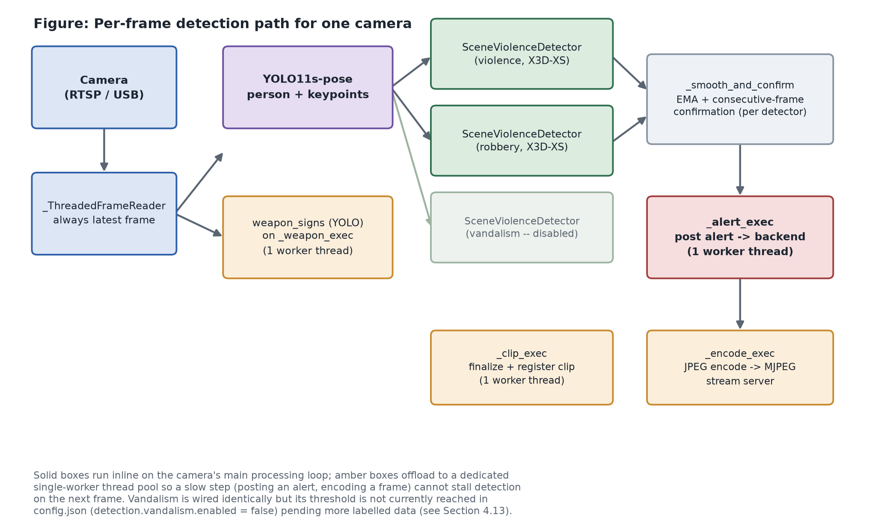
Figure 4.12: Per-Frame Detection Pipeline for One Camera
X3D-XS, the architecture behind all three category detectors, was chosen specifically for its small size -- about 3 million parameters -- which is what makes it possible to run three instances of it at once on a single consumer GPU (the development machine's GTX 1660 SUPER, with 6 GB of memory), with room left over for the pose and weapon models running alongside them. This was confirmed by direct measurement on the actual hardware, not assumed (Chapter III, Development Phase).
4.13 How the Detectors Run at the Same Time
"Running at the same time" actually means two different things here. First, the three category detectors do not run as separate, competing processes -- they run one after another, in a fixed order, on every single frame. This is affordable only because each individual pass is cheap; running three in sequence on every frame would be too slow otherwise. Second, and separately, four supporting jobs -- checking for weapons, sending a confirmed alert to the system, saving an incident clip, and preparing frames for the live dashboard -- are each handed off to their own dedicated background worker instead of being done inline. The camera feed itself is also read on its own background thread. The result is that a slow step, such as sending an alert over the network, never holds up the detectors from processing the next frame.
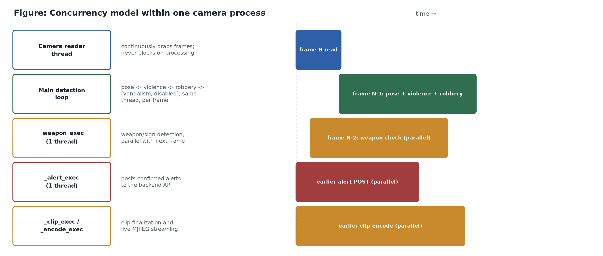
Figure 4.13: How Detection Tasks Overlap Within One Camera
This design keeps one camera responsive, but it does not by itself scale to many cameras at once: the current implementation runs one full pipeline per camera, with nothing shared between cameras. Running the detectors only where people are actually visible, rather than on every frame regardless of activity, is recorded in Section 4.10 as the main remaining step toward supporting multiple cameras from a single GPU.
4.14 October 2026 Update: Learned Robbery and Vandalism Detection and a Second-Stage Alarm Check
Sections 4.1 through 4.13 report the system as it was measured in August 2026. Between August and October the system changed in ways that overturn several earlier statements, and the measurement protocol itself became stricter. This section reports the system as it stood on 22 October 2026. Where it conflicts with an earlier section, this section supersedes it.
4.14.1 What changed
Violence detection now averages two X3D-XS models. The first was retrained with 821 fight clips and 835 calm clips cut from UCF-Crime at the event times of the UCA annotations (CVPR 2024), so that the same shops and streets appear on both sides of the label. The second was trained with false alarms mined from the training cameras; alone it catches 83.5 percent of fights, but averaged with the first the two make different mistakes. Each alarm is also confirmed against crops around the groups of people found by the pose model, which can only veto an alarm and never add one. A whole-frame score of at least 0.8 is allowed through when the pose model has found nobody for six consecutive checks, which recovers fights in blurry footage.
Weapon detection uses a YOLO11 model run at 960 pixels and fine-tuned on 7,500 synthetic street-camera frames, made by pasting real gun and knife cut-outs at the wrists of real people in the project's own Davao footage. False weapon detections on weapon-free street footage fell from 909 to 112 per hour; an armed-threat alert additionally requires the weapon to be assigned to a person for four frames. Robbery and vandalism are no longer rule-based: both are X3D-XS classifiers, labelled experimental in the application, and vandalism uses person-crop confirmation like violence.
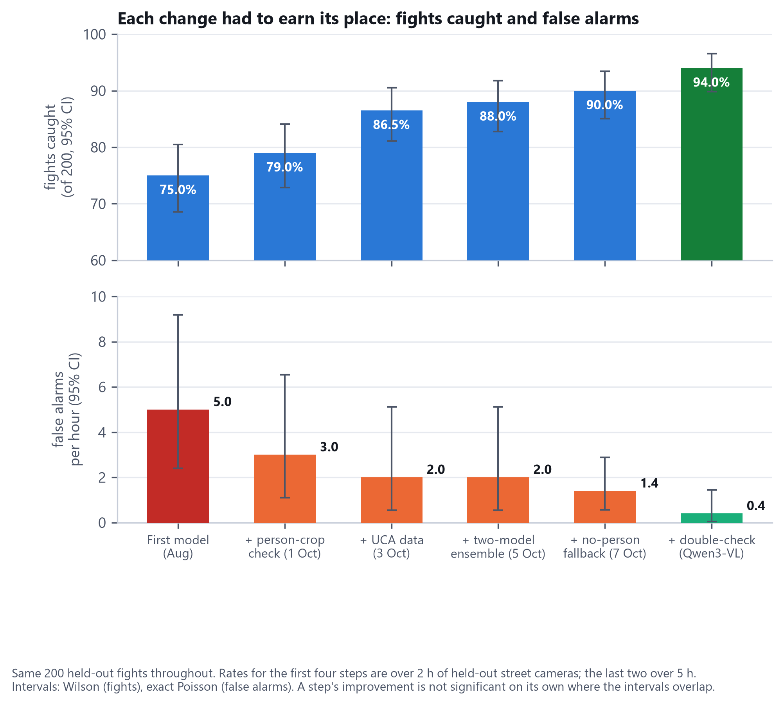
Figure 4.14: Fights Caught and False Alarms per Hour, One Change at a Time, With 95 Percent Confidence Intervals
Figure 4.14 shows the effect of each change on the same 200 held-out fights. Fights caught rose from 75.0 to 90.0 percent and false alarms fell from 5.0 to 1.4 per hour before the second-stage check was added. Each step was kept only if it improved on the previous one on identical footage; several ideas, including a robbery retrain on 737 UCF-Crime clips, a robbery model started from the violence model, and a second weapon detection pass on crops around each person, were measured and rejected.
4.14.2 Training data and measurement protocol
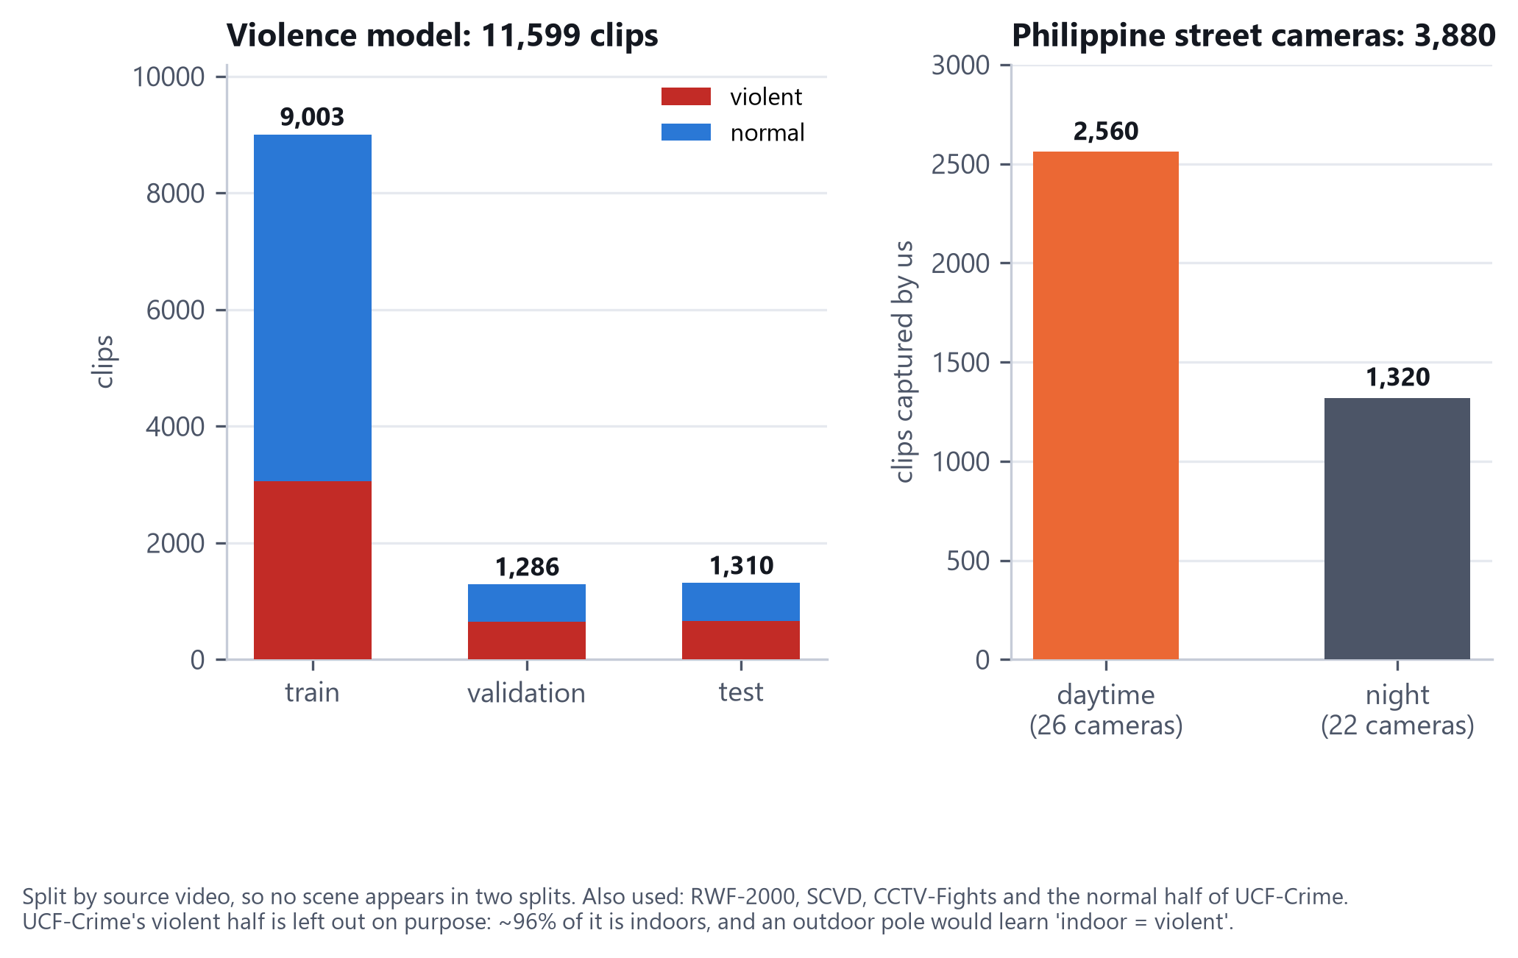
Figure 4.15: Composition of the Violence Training Data and the Locally Captured Clips
The violence model was trained on 9,003 clips and validated and tested on 1,286 and 1,310, split by source video so that no scene appears in two splits. The project's own captures contribute 3,880 clips: 2,560 daytime clips from 26 street cameras and 1,320 night clips from 22. Public datasets (RWF-2000, SCVD, CCTV-Fights and the normal half of UCF-Crime) make up the rest. The violent half of UCF-Crime is left out on purpose, because about 96 percent of it is indoors and a model trained on it would learn that indoors means violence. Every dataset was inspected by eye before training; wrong labels were found more than once.
Two quantities are reported throughout. Events caught is the share of held-out crime clips, spliced into continuous street footage, for which an alarm starts between the start of the event and three seconds after its end: 200 fights, each from a different source video, 133 robbery events and 31 vandalism acts. False alarms per hour is the number of alarms raised on five hours of street cameras that were excluded from all training and contained nothing criminal. Both are scored through the same smoothing and confirmation rules that the application runs.
4.14.3 The second-stage alarm check
The fast detectors run at a looser setting, and each alarm is passed to Qwen3-VL-2B, a small vision-language model, together with the two seconds of video that preceded it (eight frames). The model is asked a fixed yes-or-no question, such as whether anyone in the clip is fighting, punching, kicking or attacking another person, and the alarm proceeds only if the log-probability of Yes minus that of No reaches a cut-off. The model is used exactly as released; nothing about it was retrained. Each cut-off was chosen as the value that keeps a fixed share of the true alarms, fitted on half of the source videos and scored on the other half. Long candidate alarms are re-checked every seven seconds, because eight of the fifteen fights left unchecked had begun while an earlier candidate was already active.
The check runs in one of three ways, chosen automatically at start-up: on the graphics processor (about seven seconds per check and 4.2 gigabytes of video memory, during which the detectors slow from about 15 to about 2 frames per second), on the central processor through a four-bit version of the same model (about 15 seconds, 2.1 gigabytes of memory, with the detectors keeping about 85 percent of their speed), or not at all when memory is short, in which case every detector reverts to its stricter first-stage setting. A larger variant, Qwen3-VL-4B, was no better and took about 32 seconds per alarm, and an embedding-based verifier was slightly worse.
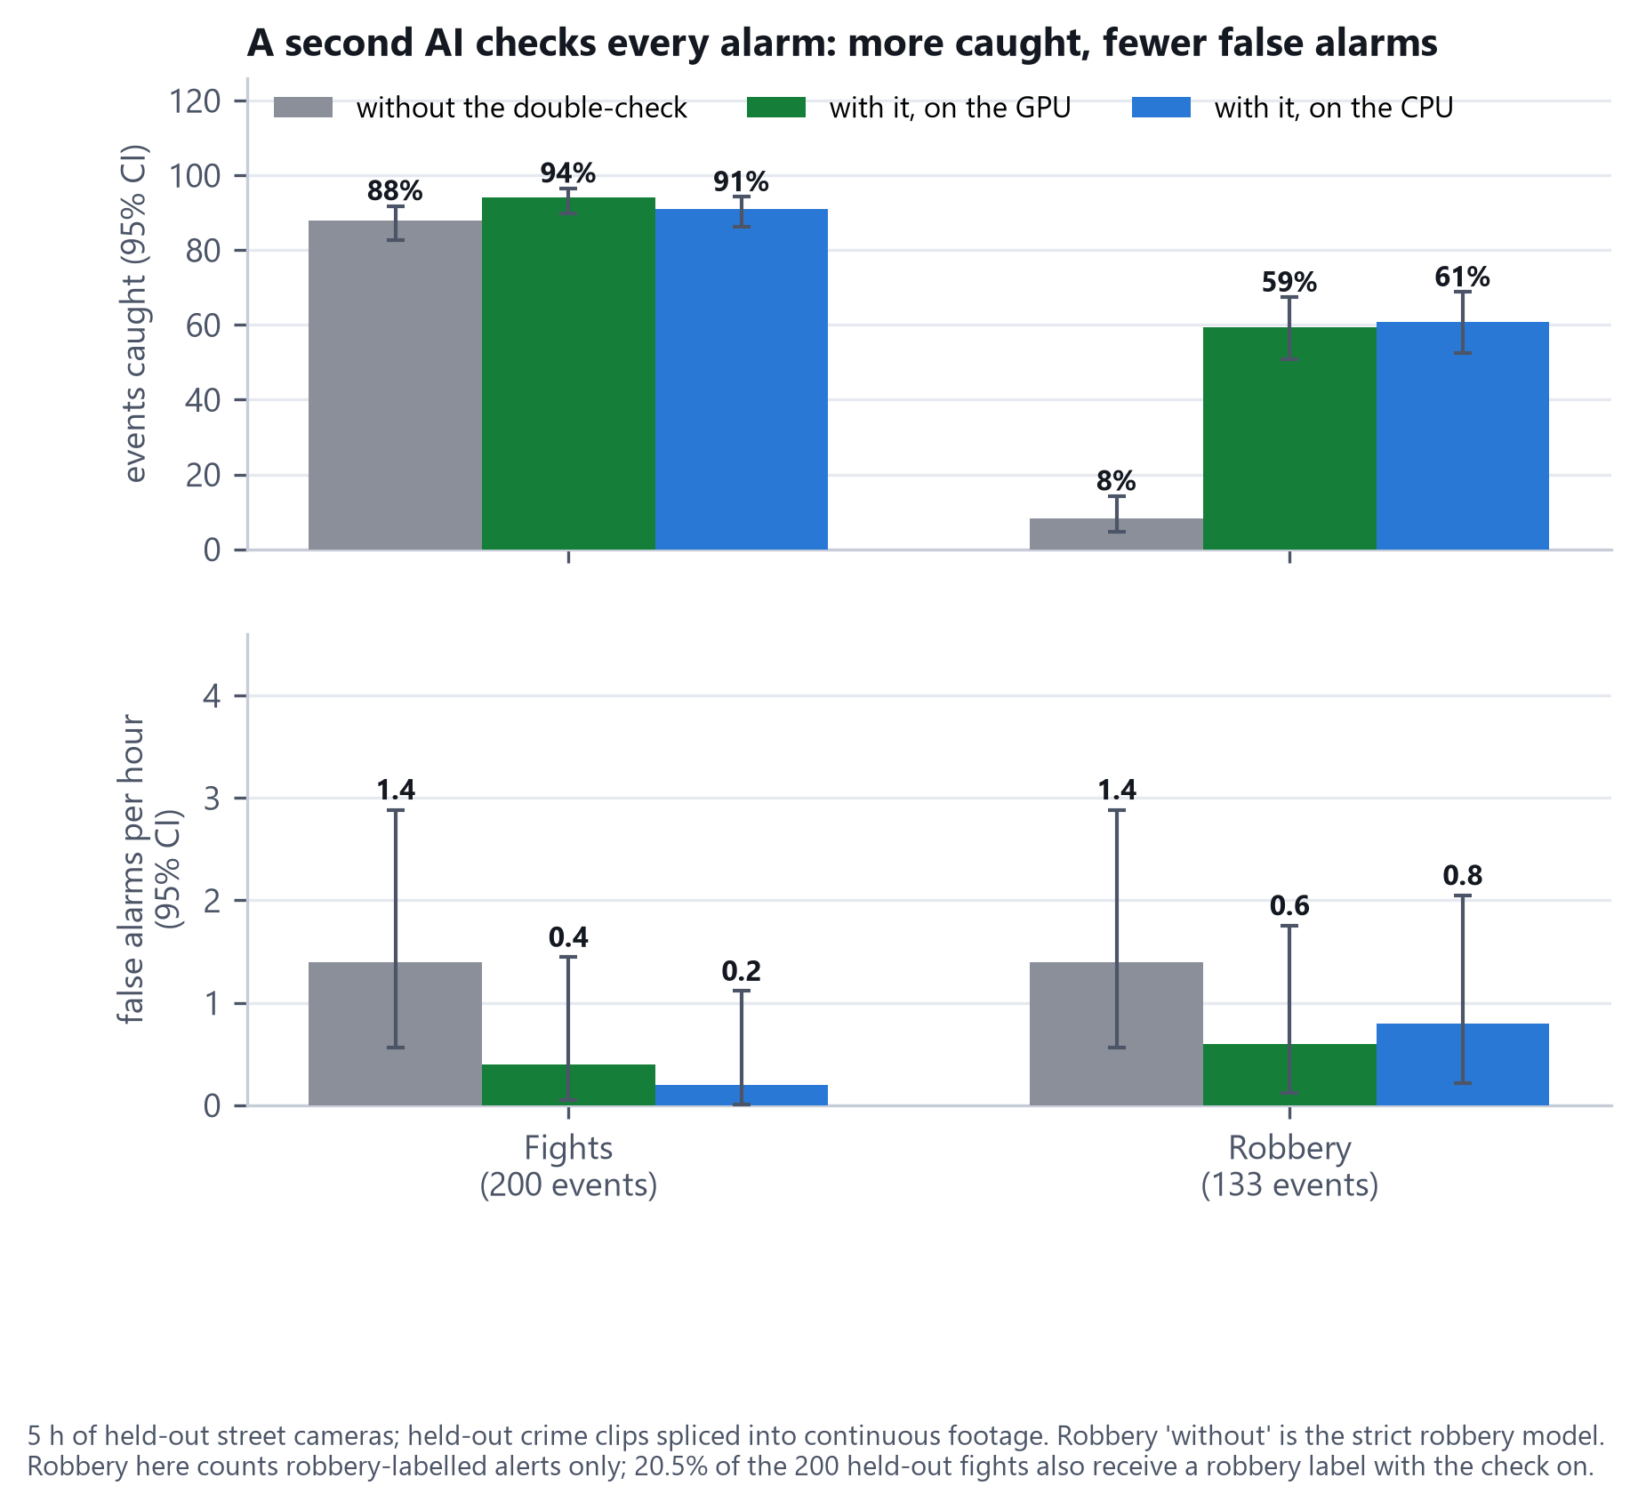
Figure 4.16: Effect of the Second-Stage Check on Fights and Robbery, Graphics-Processor and Processor Backends
Figure 4.16 shows the result. With the check on the graphics processor, 94.0 percent of fights were caught at 0.4 false alarms per hour, against 88.0 percent at 1.4 without it; on the processor backend the figures were 91.0 percent at 0.2. Robbery rose from 8.3 to 59.4 percent of events labelled as robbery, at 0.6 false alarms per hour.
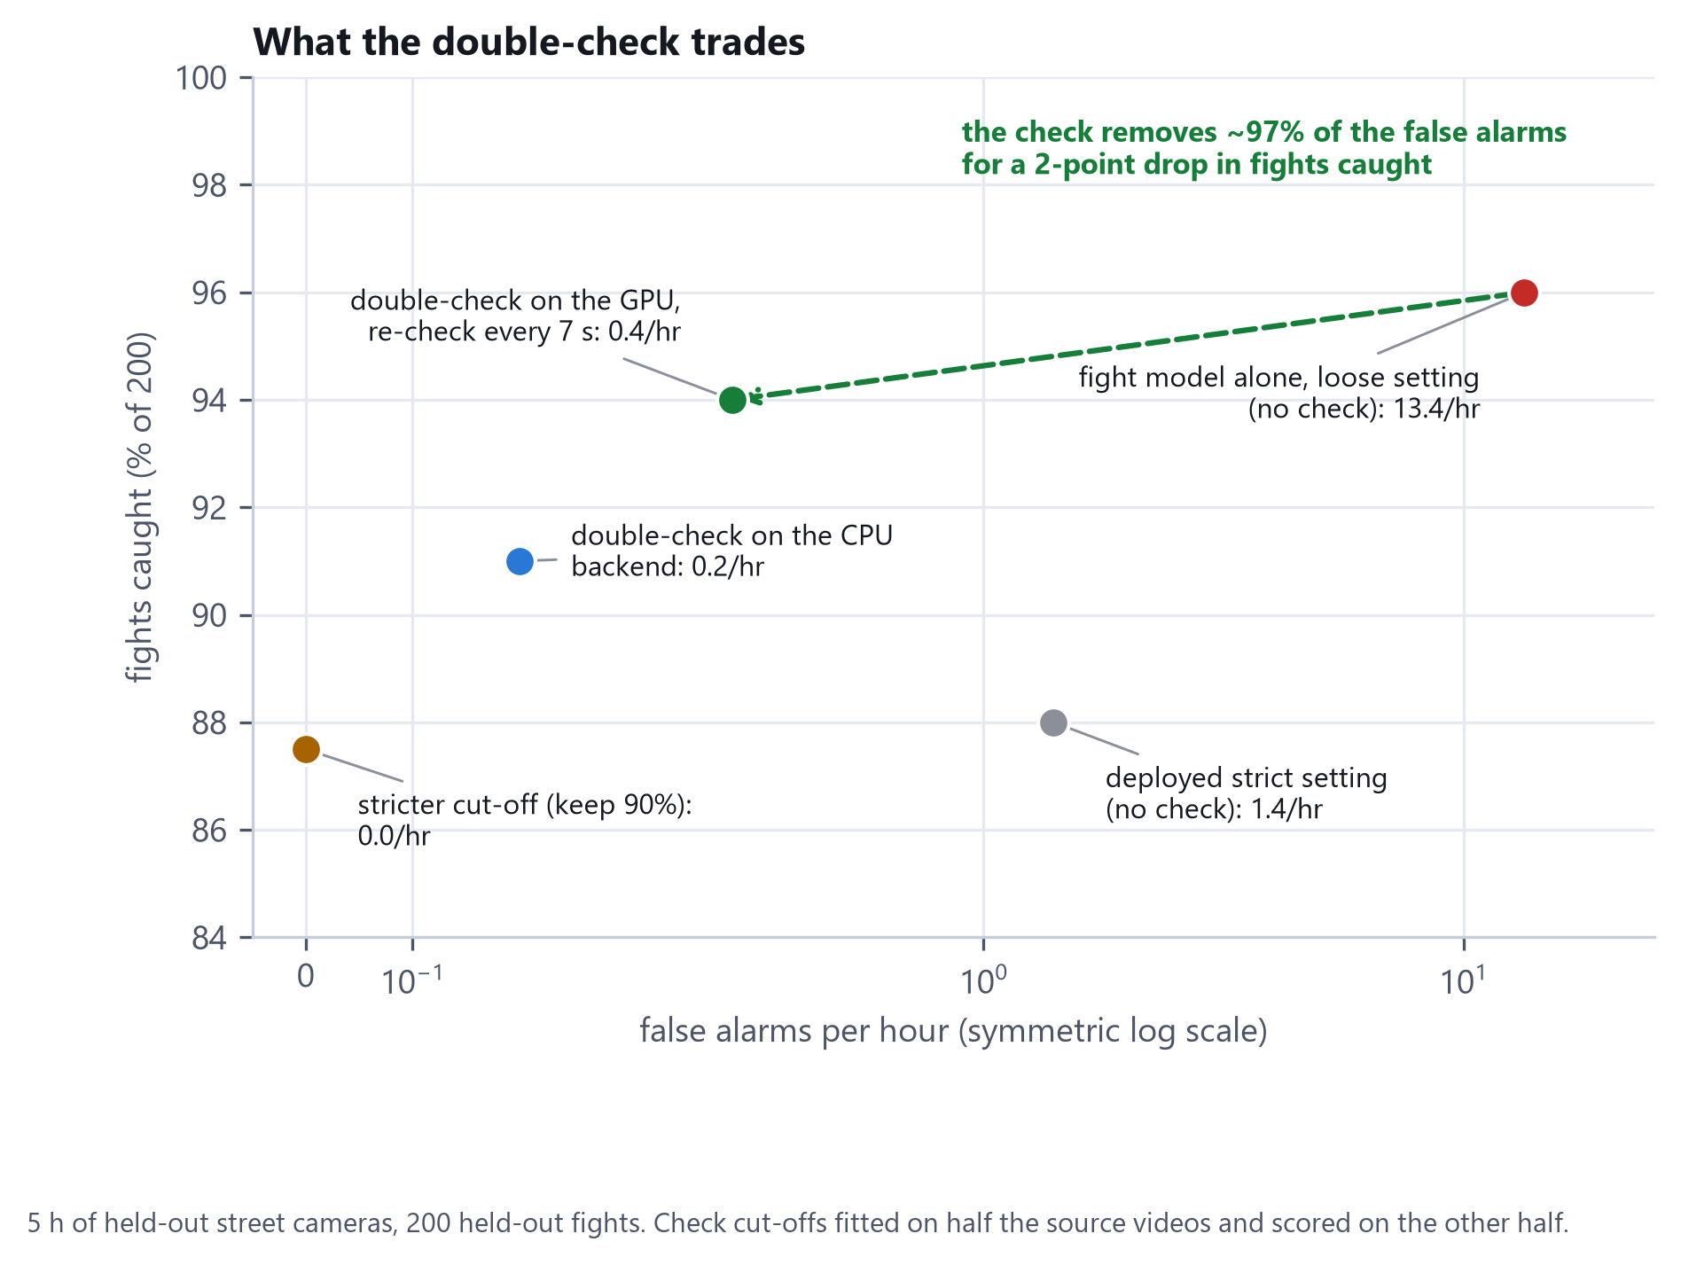
Figure 4.17: The Trade Made by the Second-Stage Check
Figure 4.17 shows what the check trades. The loose first-stage setting alone catches 96.0 percent of fights but raises 13.4 false alarms per hour. The check removes about 97 percent of those false alarms at the cost of two points of fights caught. A stricter cut-off removes the remaining false alarms but catches only 87.5 percent.
4.14.4 Robbery, and a measurement that changed the design
Street robbery is mostly a struggle that the robbery classifier rarely flags and the fight detector sees well, so the fight detector's whole-frame score supplies the candidates and the second-stage model is asked whether a robbery is happening. The first version used one yes-or-no question and appeared to work: 69.2 percent of robbery events were labelled as robbery. Scoring the same rule on the 200 held-out fights showed that it also labelled 86 percent of the fights as robbery, so the gain was largely the question passing violent clips. A second multiple-choice question was added, asking whether the clip shows a fight, a robbery or theft, or nothing, and the alarm is labelled robbery only if robbery is scored above fight. Figure 4.18 shows the sequence.
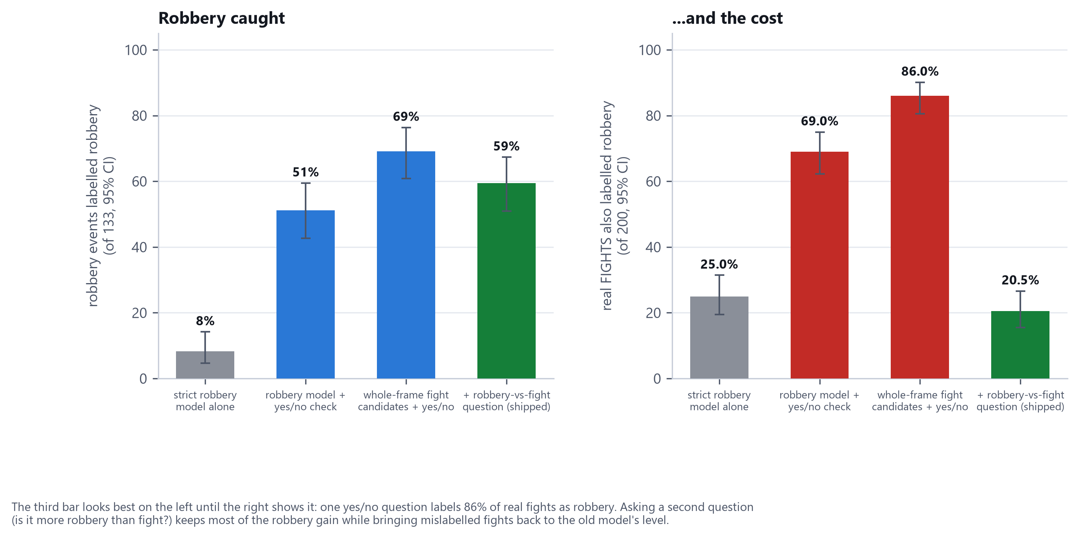
Figure 4.18: Robbery Caught Against Fights Mislabelled as Robbery, for Each Design
The shipped rule labels 59.4 percent of robbery events correctly and mislabels 20.5 percent of fights, below the 25 percent of the older robbery model. The two keep rates, 98 percent for the first question and 80 percent for the second, were chosen from eight pairs after seeing the results by a single rule, the most robbery recall with fights mislabelled no more often than before; they are not independent of the test data.
4.14.5 Weapons
No armed-threat alert rate had been measured before October, only raw detections. Replaying the application's own weapon pipeline on the same five hours gave 14 alerts, 2.8 per hour, the largest source of false alarms in the system; every one was inspected and every one was false (phones held in a hand, bag straps, shirt prints, a belt, market stalls). Each alert now waits for the question of whether the person is holding a gun or a knife, asked on a square crop around that person cut from full-resolution frames. Figure 4.19 shows the result.
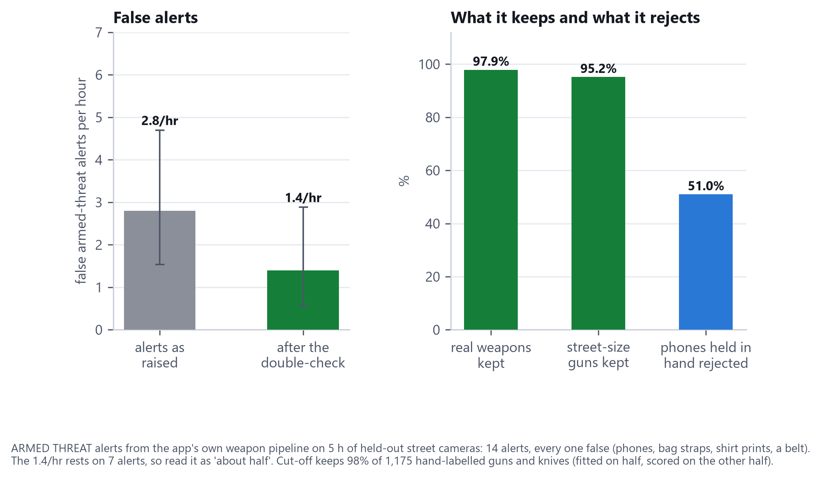
Figure 4.19: Armed-Threat False Alerts per Hour, and What the Weapon Check Keeps and Rejects
The false alert rate halved to 1.4 per hour, while 97.9 percent of real weapons and 95.2 percent of street-size guns were kept, and half of the phones held in a hand were rejected. A stricter cut-off would have reduced false alerts to 1.0 per hour but missed one street-size gun in eight, which was judged too costly for an armed-threat alarm. The check is available on the graphics-processor backend only; on the processor backend weapon alerts are sent unchecked.
4.14.6 Fights still missed
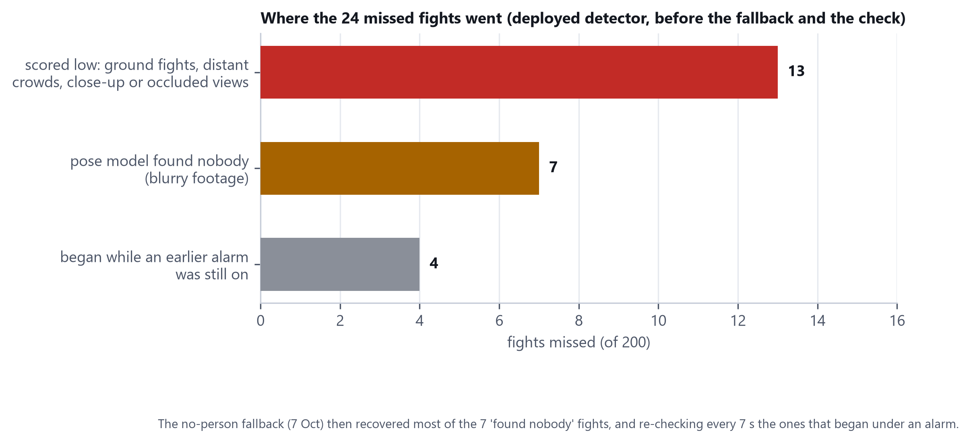
Figure 4.20: Why 24 of the 200 Held-Out Fights Were Missed by the Deployed Detector
Of the 24 fights missed by the deployed detector before the fallback and the check, 13 were scored low by the model (ground fights, distant crowd scuffles, close-up or occluded views, and three vertical phone videos unlike any surveillance footage), seven were vetoed because the pose model found nobody in blurry footage, and four began while an alarm raised a moment earlier was still active. The fallback addresses the second group and the seven-second re-check the third.
4.14.7 Statistical treatment
Recall figures are proportions of a fixed number of held-out events and are given with 95 percent Wilson score intervals. False-alarm rates are counts over a fixed number of camera-hours and are given with exact Poisson intervals. Differences between recall figures are tested with an unpaired interval, which is conservative because the same fights are scored under both settings; the per-event outcomes of the deployed baseline were not retained, so a paired test was not run. False-alarm counts are compared with an exact conditional binomial test, which is approximate because the same footage produces both counts.
Setting | Caught | n | Rate | 95% CI
Fights, deployed (no check) | 176 | 200 | 88.0% | 82.8-91.8%
Fights + check, graphics processor | 188 | 200 | 94.0% | 89.8-96.5%
Fights + check, processor | 182 | 200 | 91.0% | 86.2-94.2%
Robbery, strict model alone | 11 | 133 | 8.3% | 4.7-14.2%
Robbery + check (two questions) | 79 | 133 | 59.4% | 50.9-67.4%
Vandalism | 27 | 31 | 87.1% | 71.1-94.9%
Table 4.7: Events Caught, With 95 Percent Wilson Confidence Intervals
Setting | Alarms | Per hour | 95% CI
Fights, deployed | 7 | 1.4 | 0.6-2.9
Fights + check, graphics processor | 2 | 0.4 | 0.0-1.4
Fights + check, processor | 1 | 0.2 | 0.0-1.1
Robbery, strict model alone | 7 | 1.4 | 0.6-2.9
Robbery + check | 3 | 0.6 | 0.1-1.8
Vandalism | 3 | 0.6 | 0.1-1.8
Armed-threat alerts, no check | 14 | 2.8 | 1.5-4.7
Armed-threat alerts + check | 7 | 1.4 | 0.6-2.9
Table 4.8: False Alarms per Hour on Five Hours of Held-Out Cameras, With Exact 95 Percent Poisson Intervals
Comparison | Result | Reading
Fights caught, 94.0% vs 88.0% | +6.0 points; unpaired 95% CI 0.3 to 11.8 | Interval only just excludes zero; conservative, as the same fights are scored twice
Robbery labelled, 59.4% vs 8.3% | +51.1 points; 95% CI 40.8 to 59.9 | Clearly significant
Fight false alarms, 7 vs 2 | exact test p = 0.18 | Not significant on five hours
Armed-threat false alerts, 14 vs 7 | exact test p = 0.19 | Not significant on its own
Robbery false alarms, 7 vs 3 | exact test p = 0.34 | Not significant on five hours
Table 4.9: Does the Second-Stage Check Help? Comparisons Between Settings
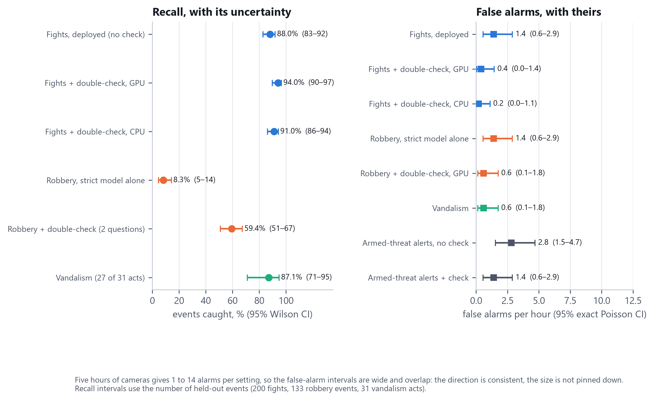
Figure 4.21: Recall and False-Alarm Rates With Their 95 Percent Confidence Intervals
The reading is as follows. The robbery gain is large and clearly real. The fight gain is smaller; its lower bound is only just above zero under the conservative unpaired test and would probably be clearer if paired. The false-alarm reductions for fights, robbery and weapons all point the same way, but each rests on between one and fourteen alarms, so none is individually significant on five hours, and more camera-hours are needed to establish how many false alarms the check removes. Figure 4.21 shows how wide the false-alarm intervals are.
4.14.8 Limitations of the October results
Recall on the deployment cameras is still unmeasured, because no labelled incident has been recorded on them. Fight clips are real held-out fights, but their setting is constructed by splicing them into street footage. The keep rates of the second-stage check were chosen after seeing results, although each cut-off was fitted and scored on separate halves of the data. The check delays an alert by about seven seconds on the graphics processor and about fifteen on the processor, and it needs memory that an eight-gigabyte laptop may not have free, in which case it stays off. On a four-gigabyte graphics card it runs on the processor, where weapon alerts are not checked. Robbery and vandalism remain experimental.
REFERENCES
All in-text citations in this manuscript, and every dataset used in Chapter III, are listed below in APA 7th edition format. Entries were verified against their original source rather than reconstructed from memory.
Ahmed, M. (2022). gun and knife detection (Version 1) [Data set]. Roboflow. https://universe.roboflow.com/mahad-ahmed/gun-and-knife-detection
Amah, G. G., Enokela, J. A., Agbo, D. O., & Iorkyase, T. E. (2025). Lightweight YOLOv8 optimized deep neural network for real-time weapon detection on Raspberry Pi 5 in smart surveillance systems. Journal of Engineering Research and Reports, 27(9). https://journaljerr.com/index.php/JERR/article/view/1688
Aremu, T., Zhiyuan, L., Alameeri, R., Khan, M., & El Saddik, A. (2024). SSIVD-Net: A novel salient super image classification & detection technique for weaponized violence [Introduces the Smart-City CCTV Violence Detection (SCVD) dataset]. Proceedings of the 2024 SAI Computing Conference. https://arxiv.org/abs/2207.12850
Berg Insight. (2025). The global smart street lighting market (3rd ed.) [Market research report]. https://www.berginsight.com/the-global-smart-street-lighting-market/
Bosun Lighting. (2025). GEBOSUN lighting and smart cities: Smart light poles [Company product documentation]. https://www.bosunlighting.com/gebosun-lighting-and-smart-cities-smart-light-poles.html
Chaudhry, U. (2022). Traffic and Road Signs (Version 1) [Data set]. Roboflow. https://universe.roboflow.com/usmanchaudhry622-gmail-com/traffic-and-road-signs
Cheng, M., Cai, K., & Li, M. (2021). RWF-2000: An open large scale video database for violence detection. In 2020 25th International Conference on Pattern Recognition (ICPR) (pp. 4183-4190). IEEE. https://doi.org/10.1109/ICPR48806.2021.9412502
dietest. (2023). Gun-cctv-detection (Version 1) [Data set]. Roboflow. https://universe.roboflow.com/dietest/gun-cctv-detection
Florin, A. F., Ugalino, M., Jr., & Aguilan, K. E. (2025). An analysis of smart city development frameworks [Policy brief]. UP Center for Integrative and Development Studies. https://cids.up.edu.ph/policy-brief/analysis-smart-city-development-frameworks/
Gao, H. (2023). A YOLO-based violence detection method in IoT surveillance systems. International Journal of Advanced Computer Science and Applications, 14(8). https://doi.org/10.14569/IJACSA.2023.0140817
Kulkarni, S. (2022). knife (Version 1) [Data set]. Roboflow. https://universe.roboflow.com/sanket-kulkarni/knife-eydvx
Perez, M., Kot, A. C., & Rocha, A. (2019). Detection of real-world fights in surveillance videos [Introduces the CCTV-Fights dataset]. ICASSP 2019 - 2019 IEEE International Conference on Acoustics, Speech and Signal Processing (ICASSP), 2662-2666. https://doi.org/10.1109/ICASSP.2019.8683676
Pudasaini, D., & Abhari, A. (2021). Edge-based video analytic for smart cities. International Journal of Advanced Computer Science and Applications, 12(7). https://doi.org/10.14569/IJACSA.2021.0120701
Republic of the Philippines. (2001). Republic Act No. 9003: Ecological Solid Waste Management Act of 2000. Official Gazette of the Republic of the Philippines. https://www.officialgazette.gov.ph/2001/01/26/republic-act-no-9003-s-2001/
Simuletic. (2025). CCTV Knife Detection Dataset (Sample Version) (Version 1) [Data set]. Roboflow. https://universe.roboflow.com/simuletic/cctv-knife-detection-dataset-zkkaf
Sultani, W., Chen, C., & Shah, M. (2018). Real-world anomaly detection in surveillance videos [Introduces the UCF-Crime dataset]. Proceedings of the IEEE Conference on Computer Vision and Pattern Recognition (CVPR), 6479-6488. https://doi.org/10.1109/CVPR.2018.00678
Uranus, H., Adhinugroho, N. R., Yulian, D. H., & Mangunsong, R. (2022). Design and realization of solar-powered IoT-based flood early warning system with Telegram messaging, auto-restart watchdog, and power management. GCISTEM Proceeding, 1. https://doi.org/10.56573/gcistem.v1i.4
workspace-1qko2. (2024). gun detection (Version 4) [Data set]. Roboflow. https://universe.roboflow.com/workspace-1qko2/gun-detection-ghlzd
workspace-zqssx. (2022). knife-dataset (Version 2) [Data set]. Roboflow. https://universe.roboflow.com/workspace-zqssx/knife-dataset-4kytl
Note: workspace-1qko2, workspace-zqssx, and dietest are Roboflow workspace handles; no further author name was published on the source pages. Bosun Lighting's entry is a company product page, not a peer-reviewed source, cited here because Chapter II relies on it as an industry case study rather than as a research finding -- treat its claims with correspondingly less weight than the peer-reviewed entries above it.

